**PROJECT-2**

**CASE STUDY**

**DONE BY**

**RANJITH KUMAR**

**APPLICATION:**

Employee profile of XYZ company – New employees input their information and upload photos. Existing employees can get their information.

STEP 1 :Open VPC from aws services

STEP 2 : Select create VPC > VPC and more

STEP 3 : Create 6 subnets(4private & 2 public), 6 route tables, Internet gateway and NAT gatyeway

STEP 4 : VPC, Subnets, Route taale ,Internetgateway and NAT gateway has been created

STEP 5 : Associate db and app subnets with the db&app route tables

STEP 6 : Open EC2

STEP 7 : Launch instance in our create vpc and subnets.(Ubuntu)

STEP 8 : Instance has been launched

STEP 9 : Create an IAM role with SSM full access to connect to the instance for secure connection(we can also use instance connect also)

STEP 10 : Open RDS

STEP 11 : Create a Subnet group for dbsubnets.(Select VPC, A.Z, subnets)

STEP 12 : Select Databases > Create Database

STEP 13 : Select MYSQL, Free tier, VPC, Subnet groups, Db name and password and neccessary information needed for database

STEP 14 : Now connect to the EC2 instance using session manager

STEP 15 : Update the instance sudo apt-get update -y

STEP 16 : Copy the link from the github and paste in the instance using command:- sudo git clone https://github.com/Training-Demo/aws-code-main.git

STEP 17 : USe commands:- sudo apt-get install python3-flask, sudo apt-get install python3-pymysql, sudo apt-get install python3-boto3 these are dependencies required

STEP 18 : Create a S3 bucket

STEP 19 : Use command:- sudo vim config.py and enter custom host, user, password, databasename, Bucket name, bucket region

STEP 20 : Use command:- sudo python3 EmpApp.py

STEP 21 : Now go the database security group > Edit inbound rules

STEP 22 : Copy the cidr of app subnet and add it to the db security group and save it

STEP 23 : Again use the command:-sudo python3 EmpApp.py Now it will be working as we updated the security group

STEP 24 : Open Load balancing > Target groups and create a target group(instances)

STEP 25 : Create a application load balancer and add the target group(Create a new security group for the load balancer)

STEP 26 : Now go to the app security group and add destination as loaD BALANCER SECURITY GROUPS

STEP 27 : Now the application load balancer starts getting response

STEP 28 : If the details entered in the site it will get a error so we should create a table

STEP 29 : Install mysql in the instance using the command:- sudo apt-get install mysql-client -y

STEP 30 : Use the command: sudo mysql -h(Endpoint) -u(Username) -p(Password) to connect to the database

STEP 31 : Show databases; , use project2 , create table employee(); commands used to create a table

STEP 32 : Restart the EmpApp.py

STEP 33: Add S3 fullaccess and dynamodb fullaccess to the IAM role attached to the instance

STEP 34 : Open DynamoDB

STEP 35 : Create a table

STEP 36 : Verify the region of the dynamodb table created in the EmpApp.py file if change needed change the needed information in it

STEP 37 : Now data are storing in teh dynamodb and mysql

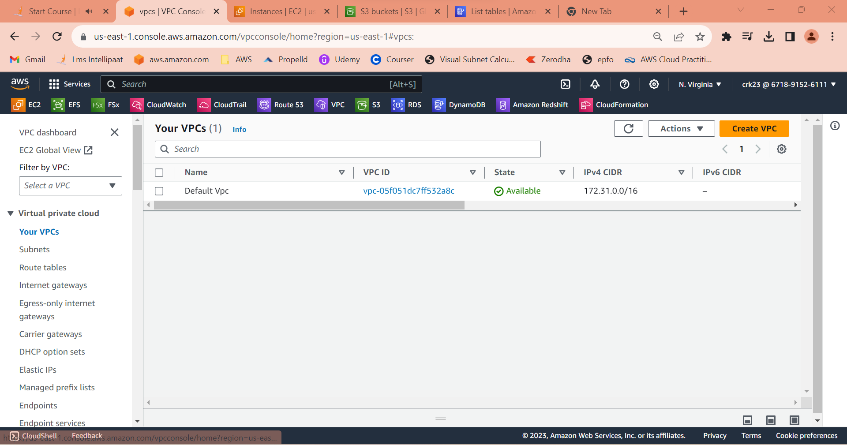

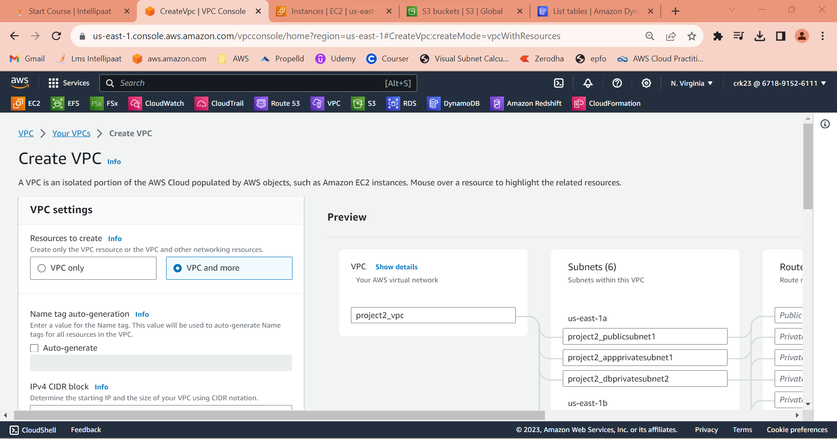

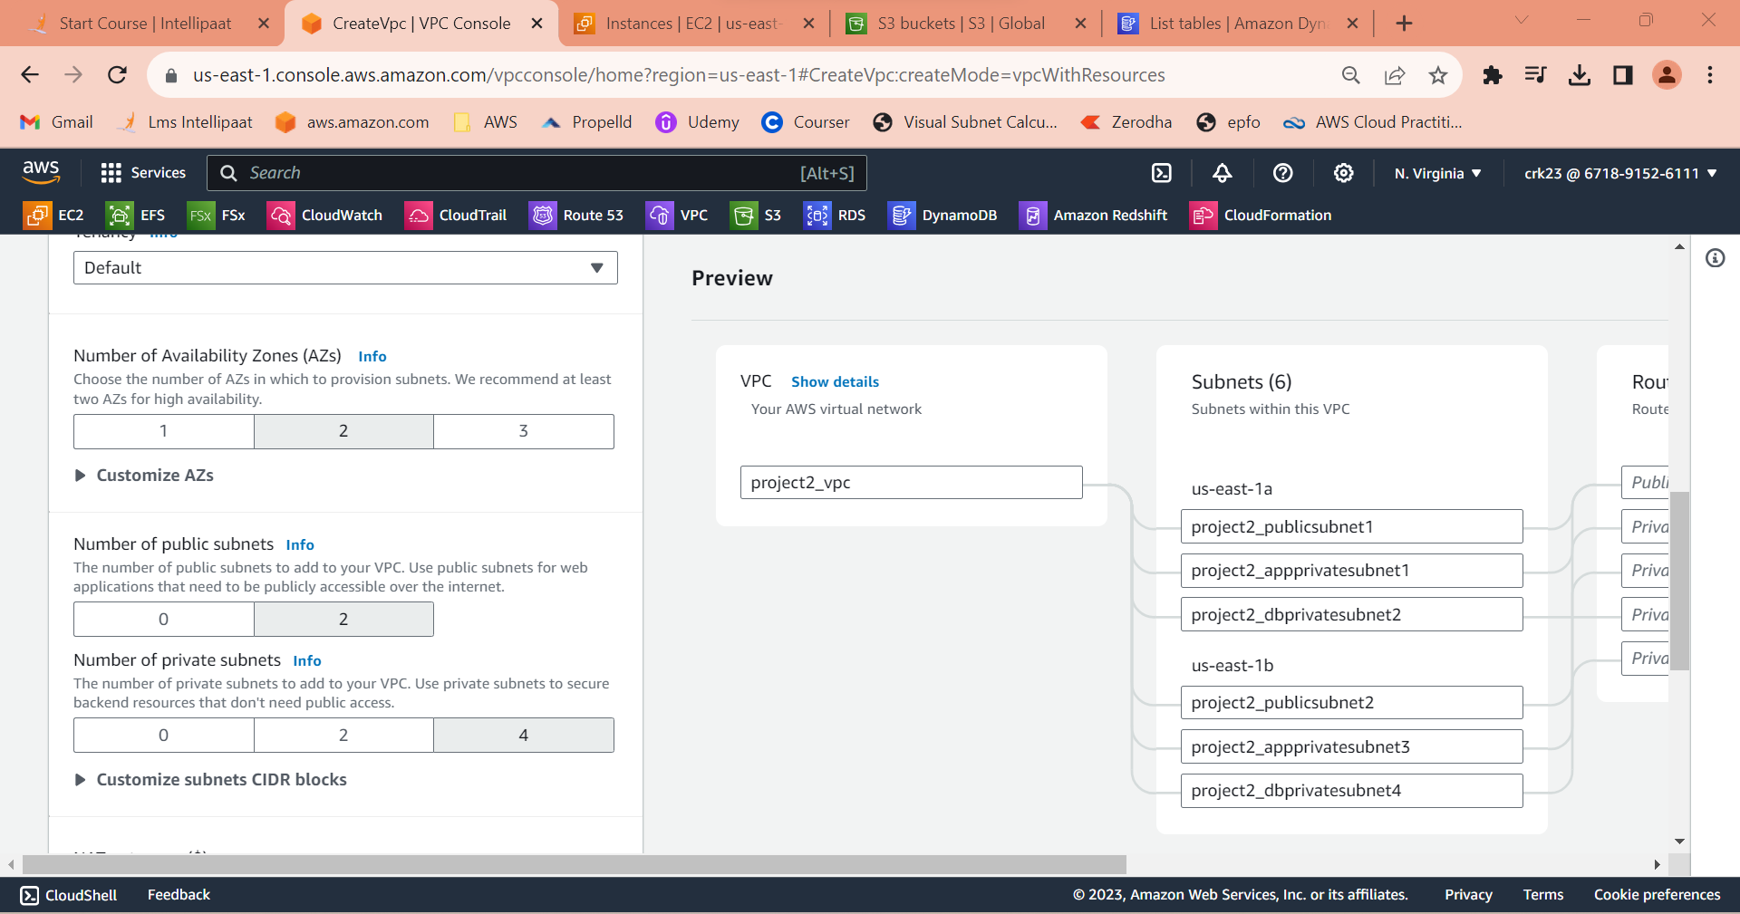

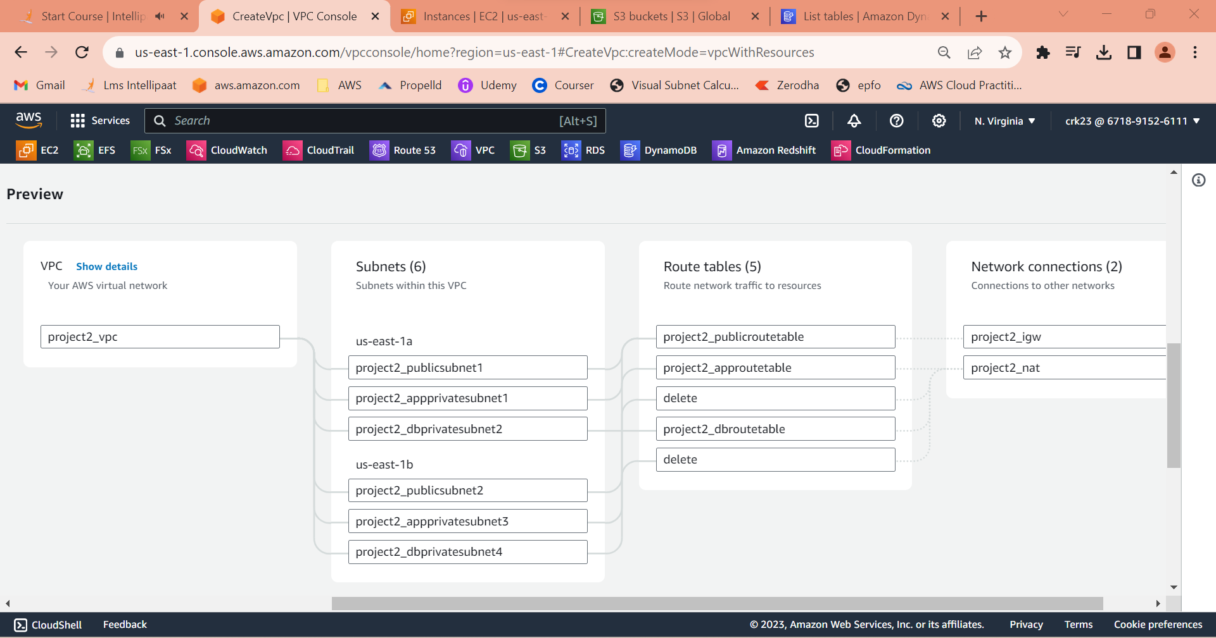

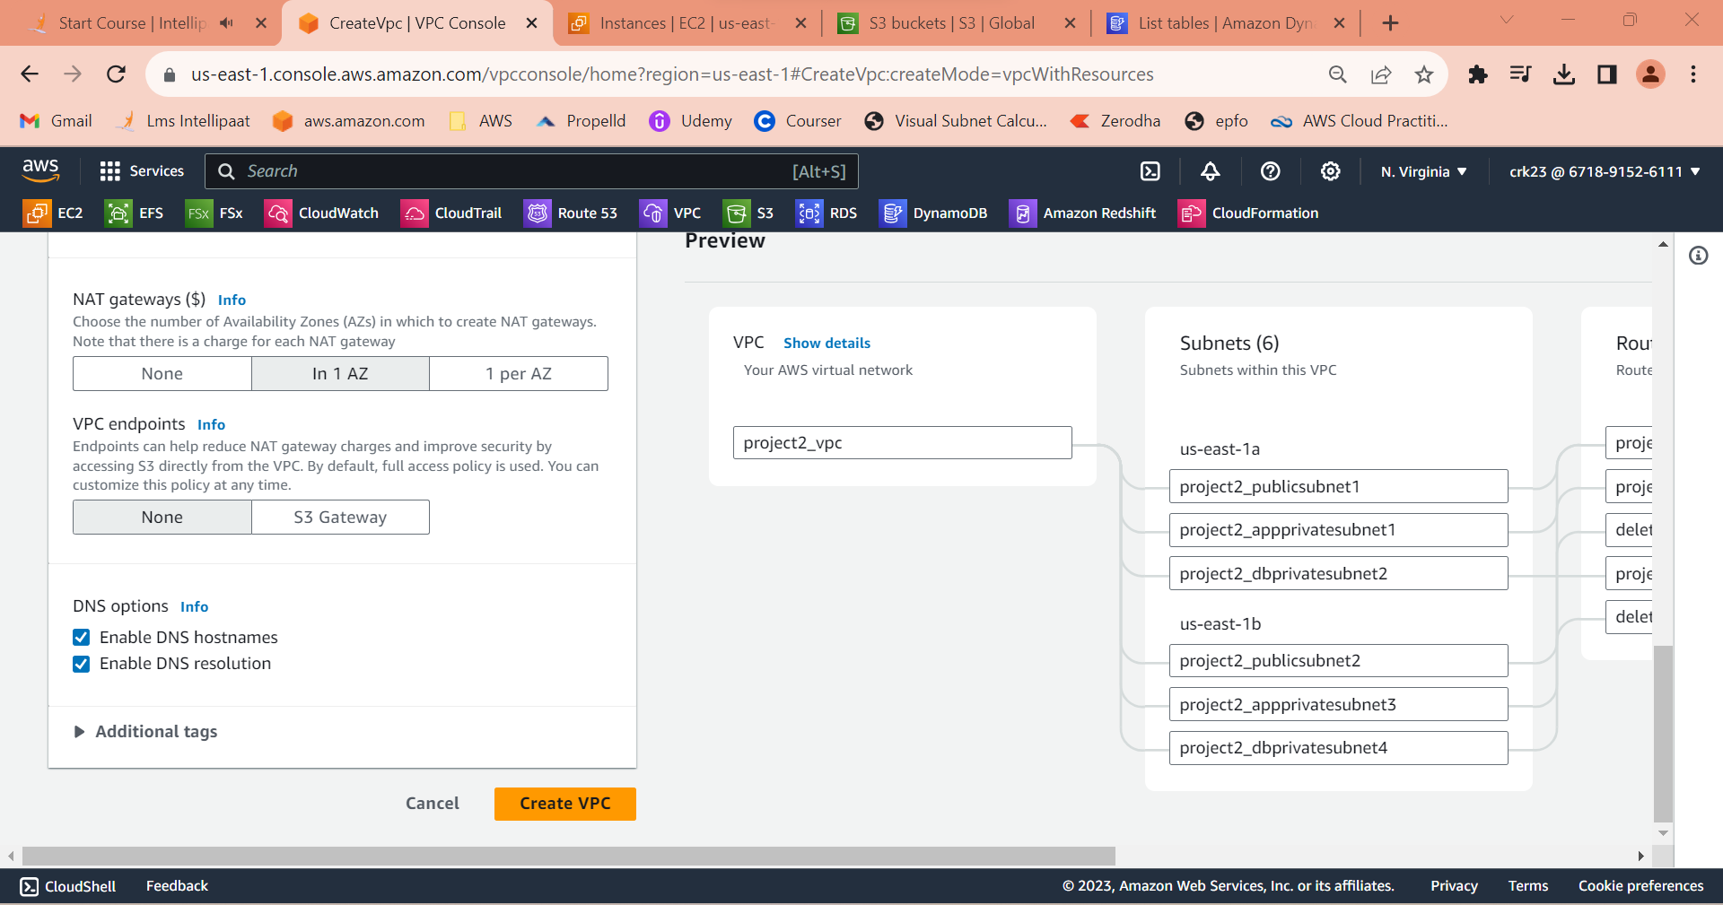

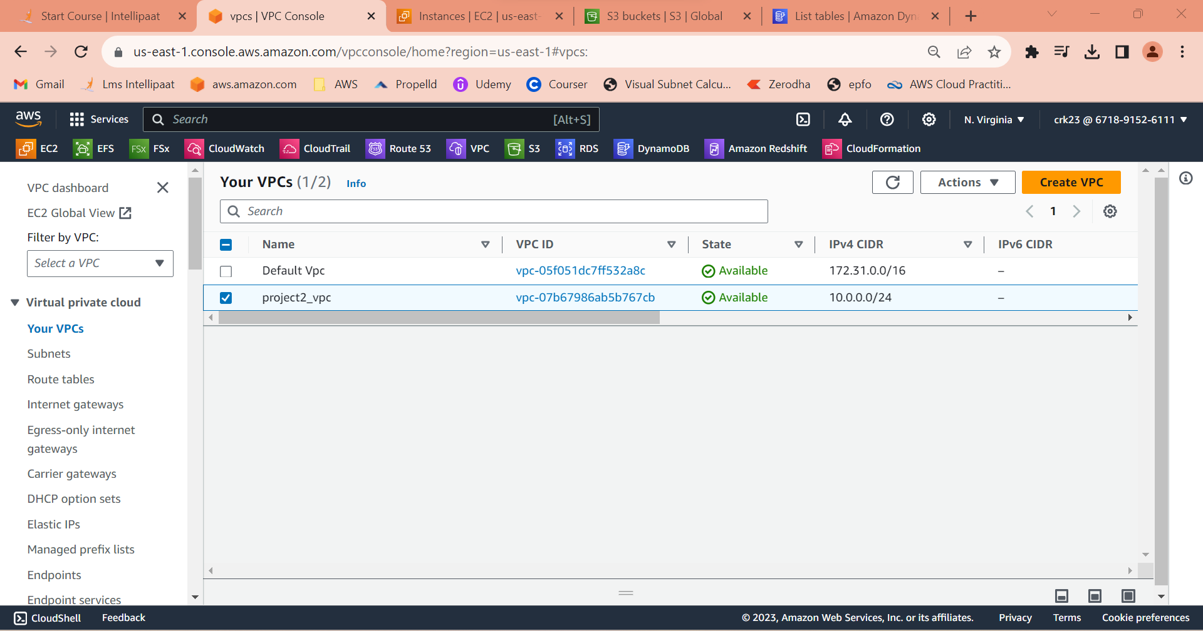

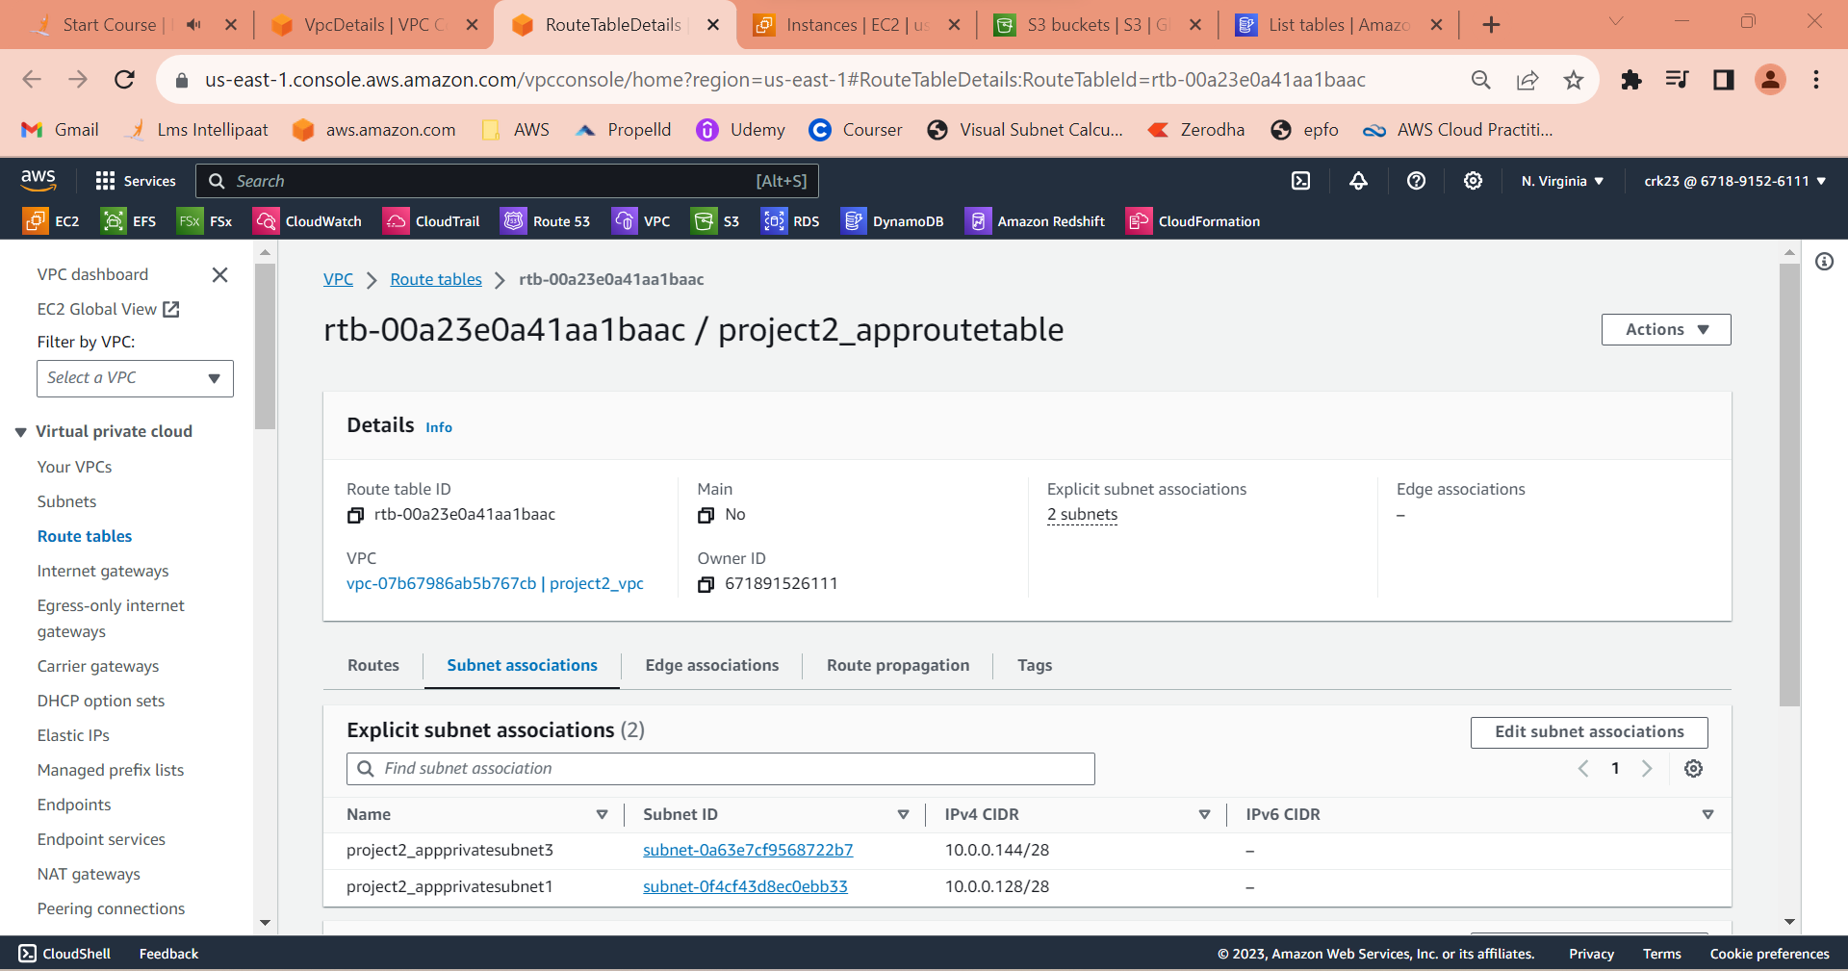

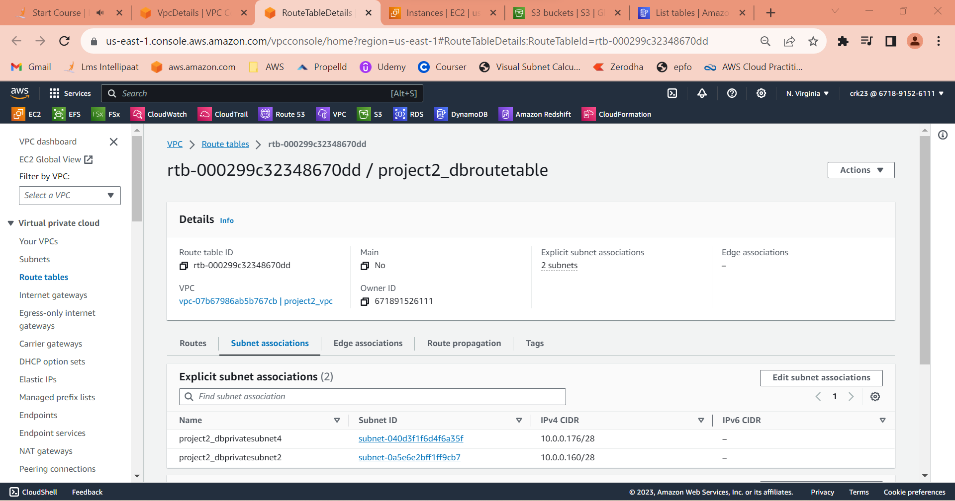

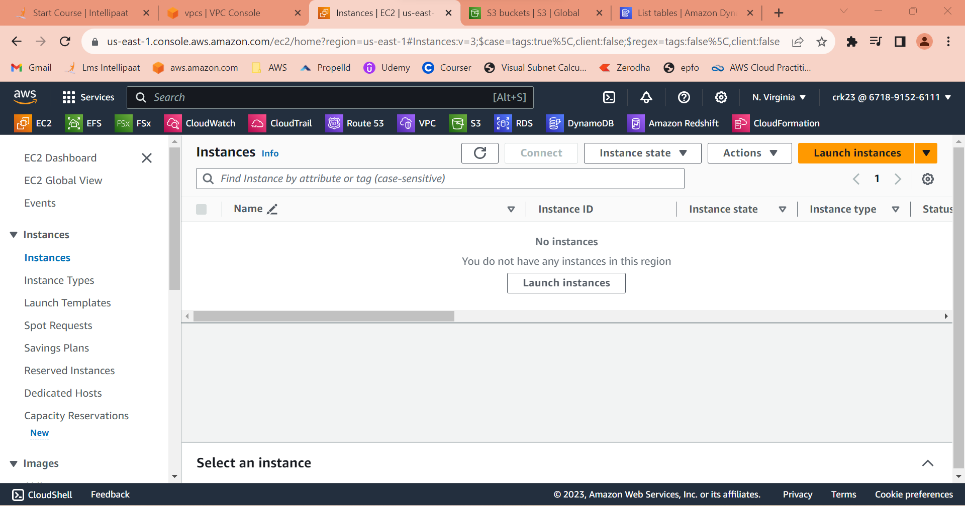

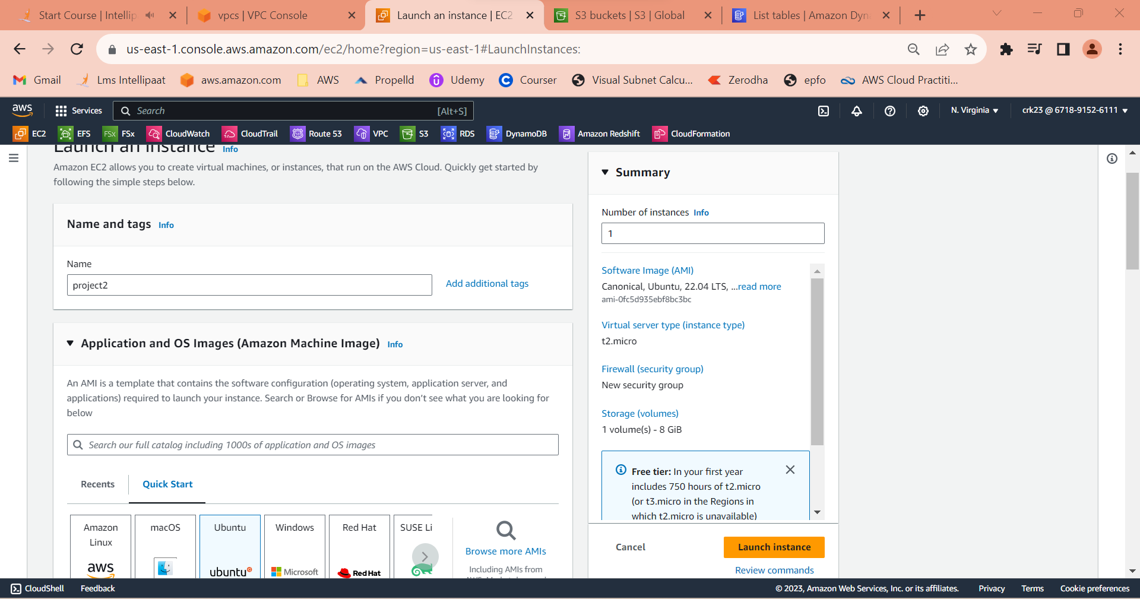

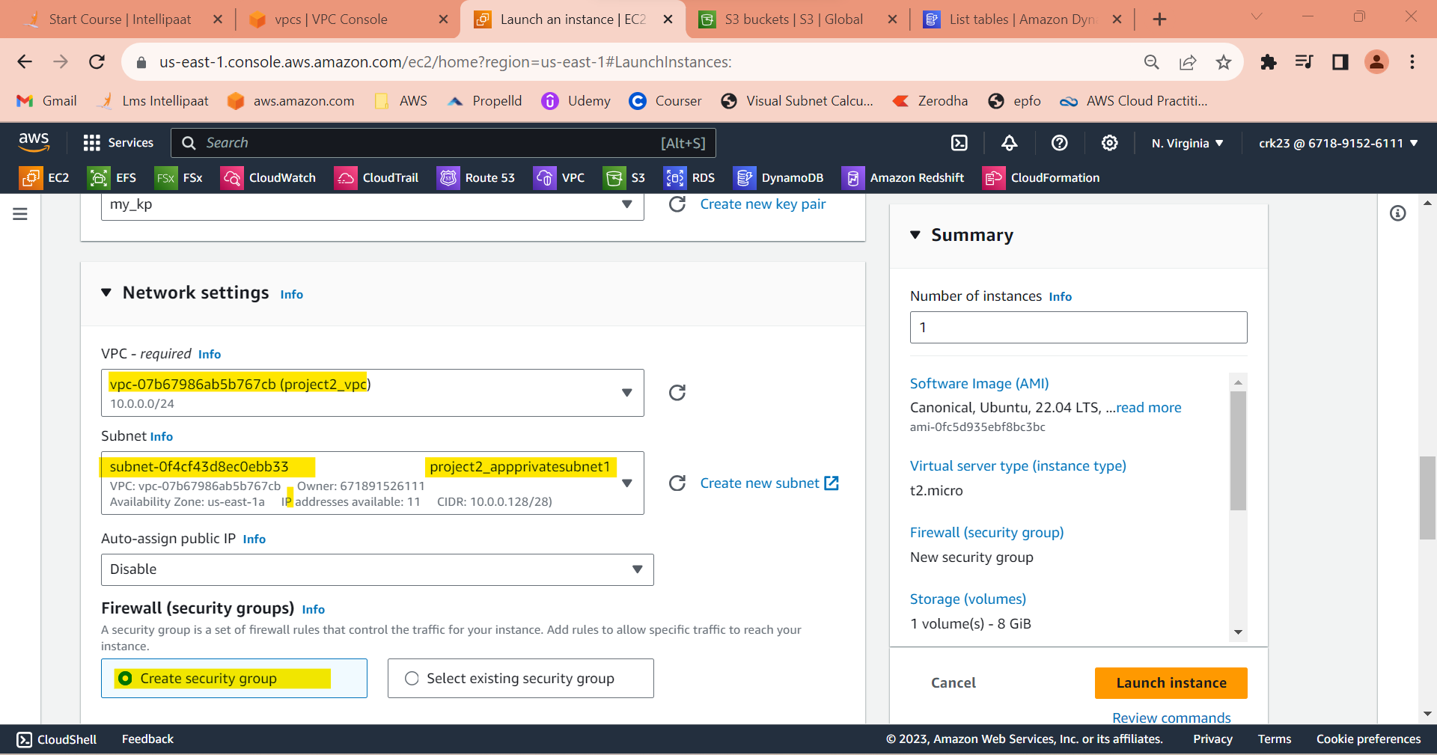

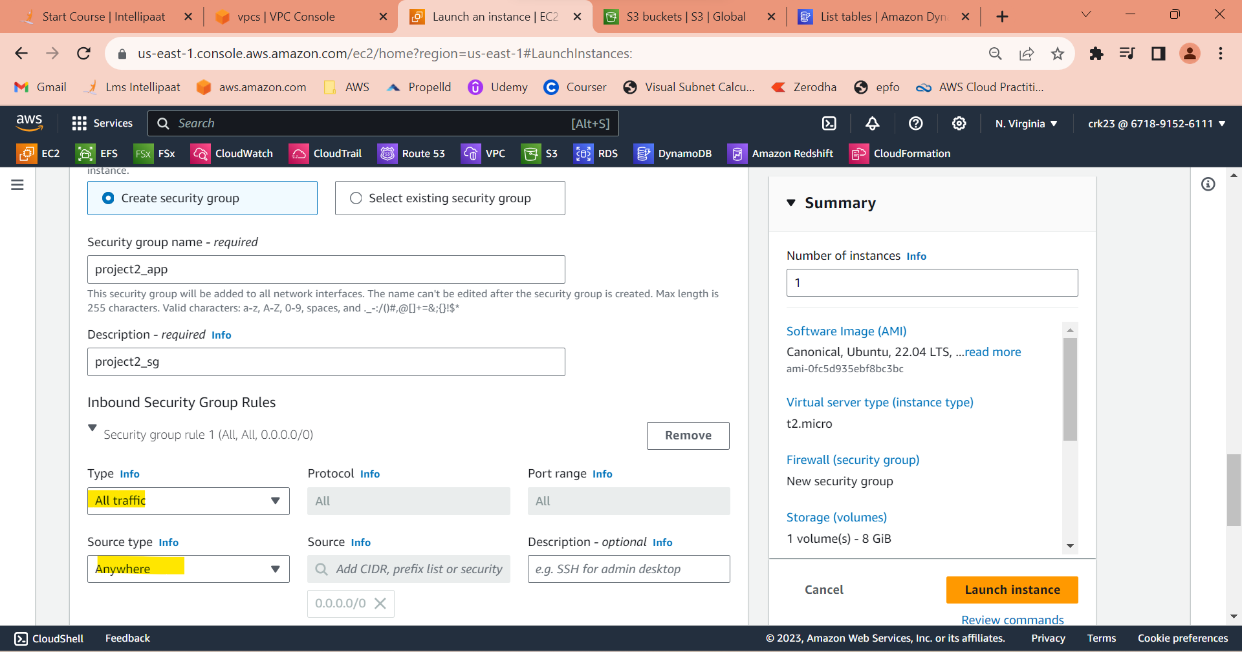

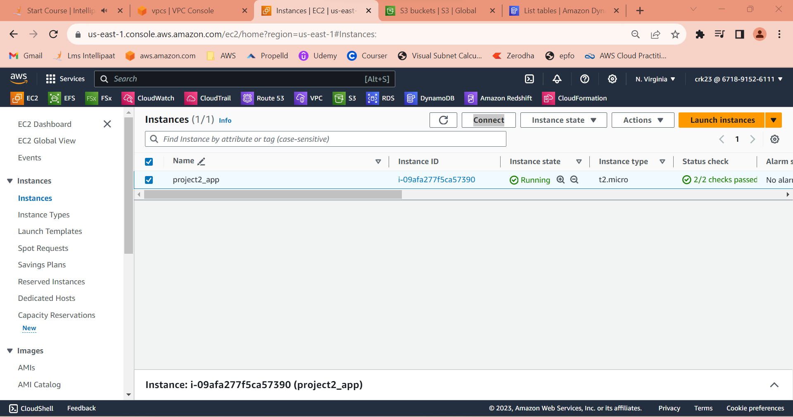

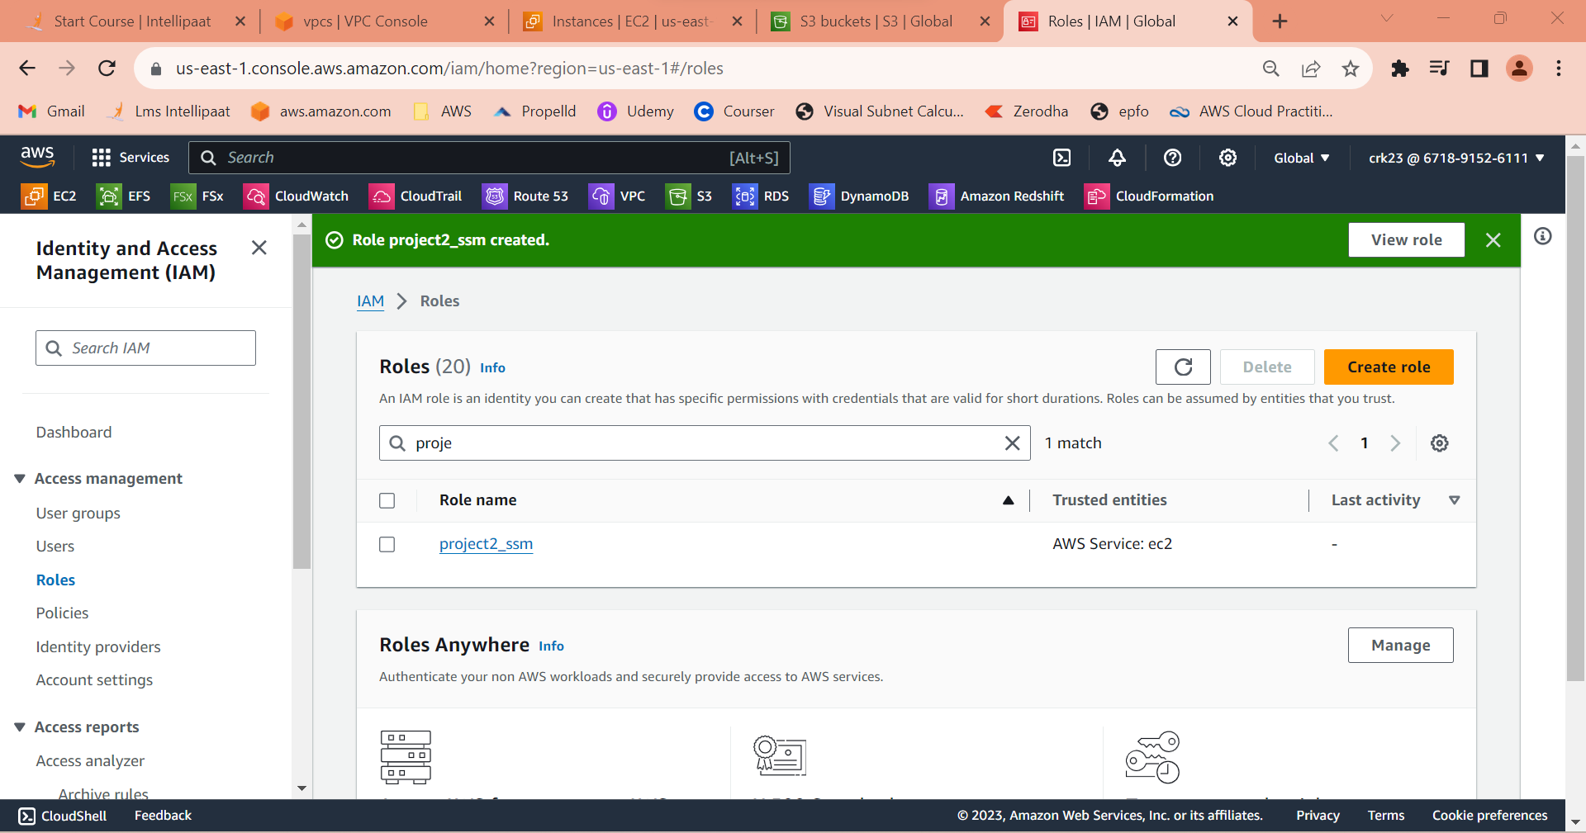

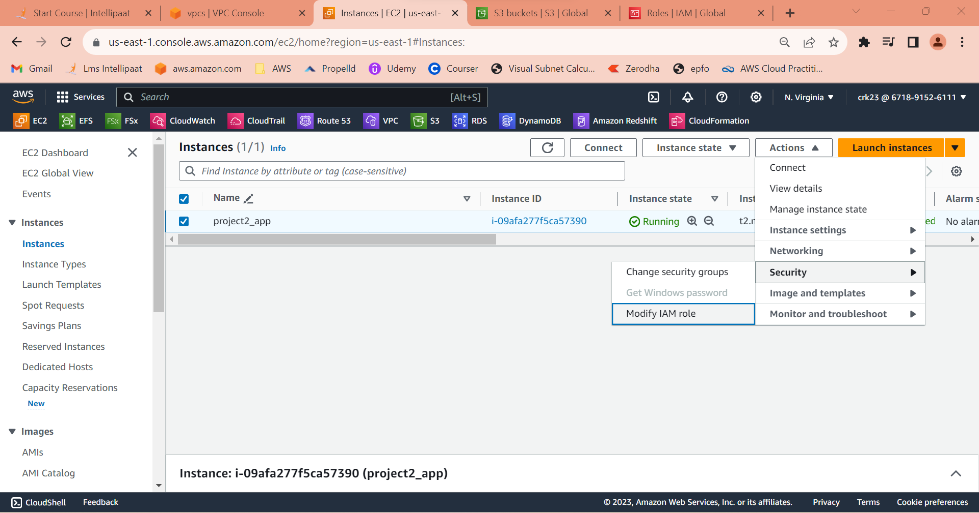

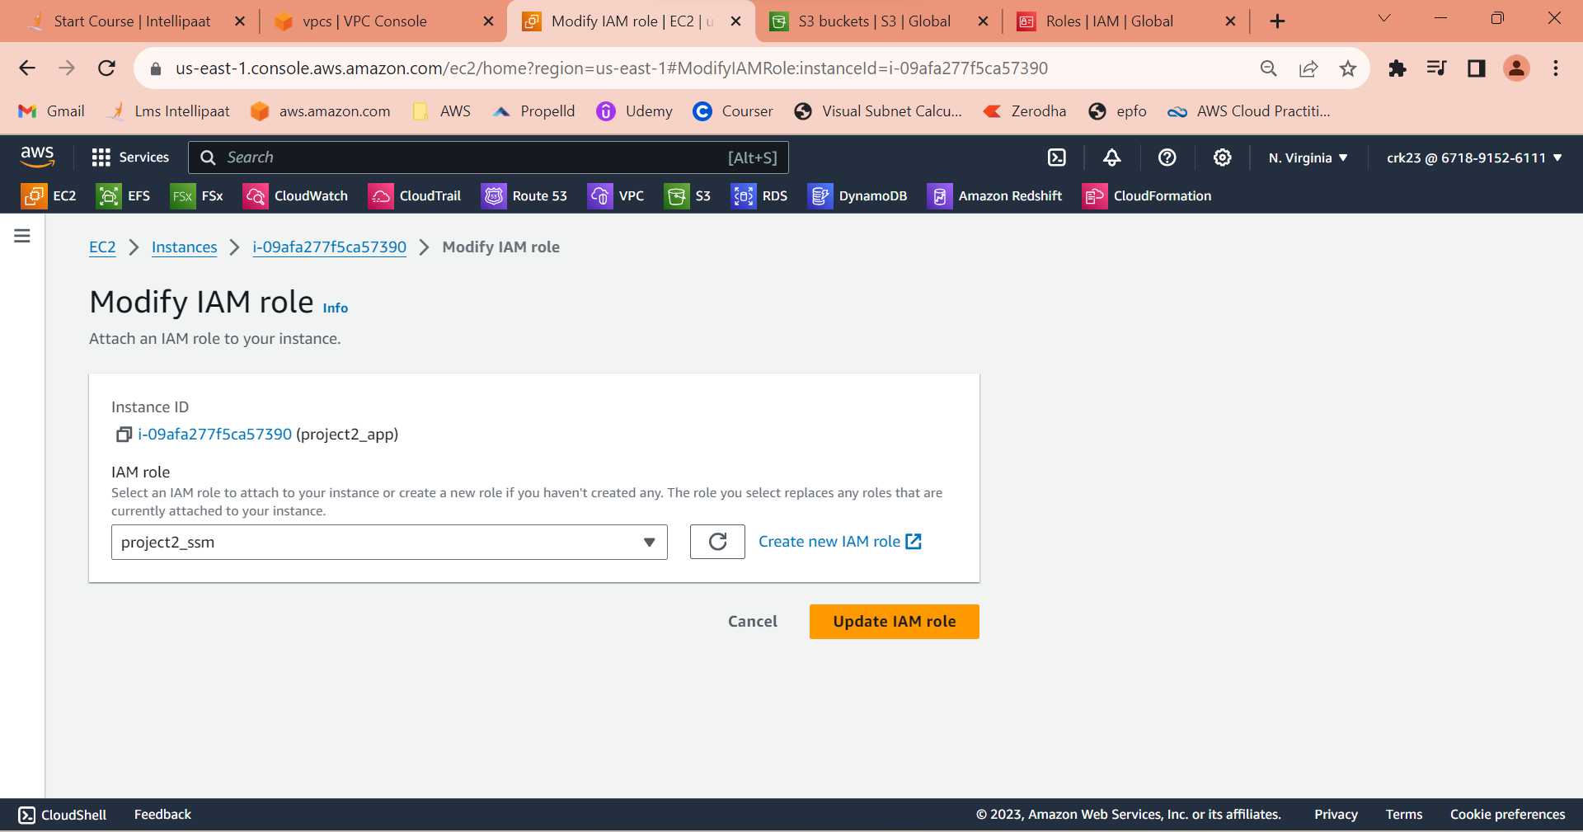

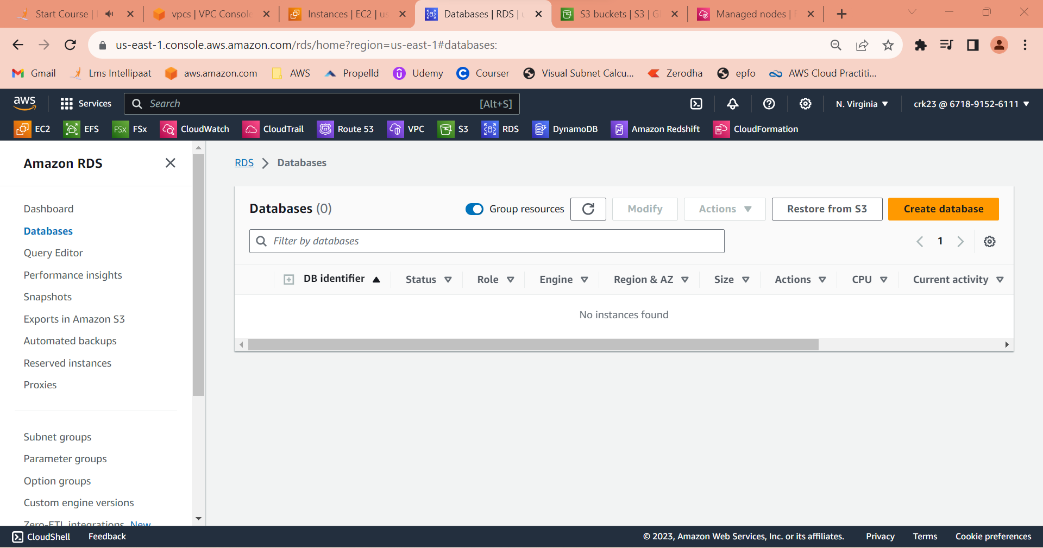

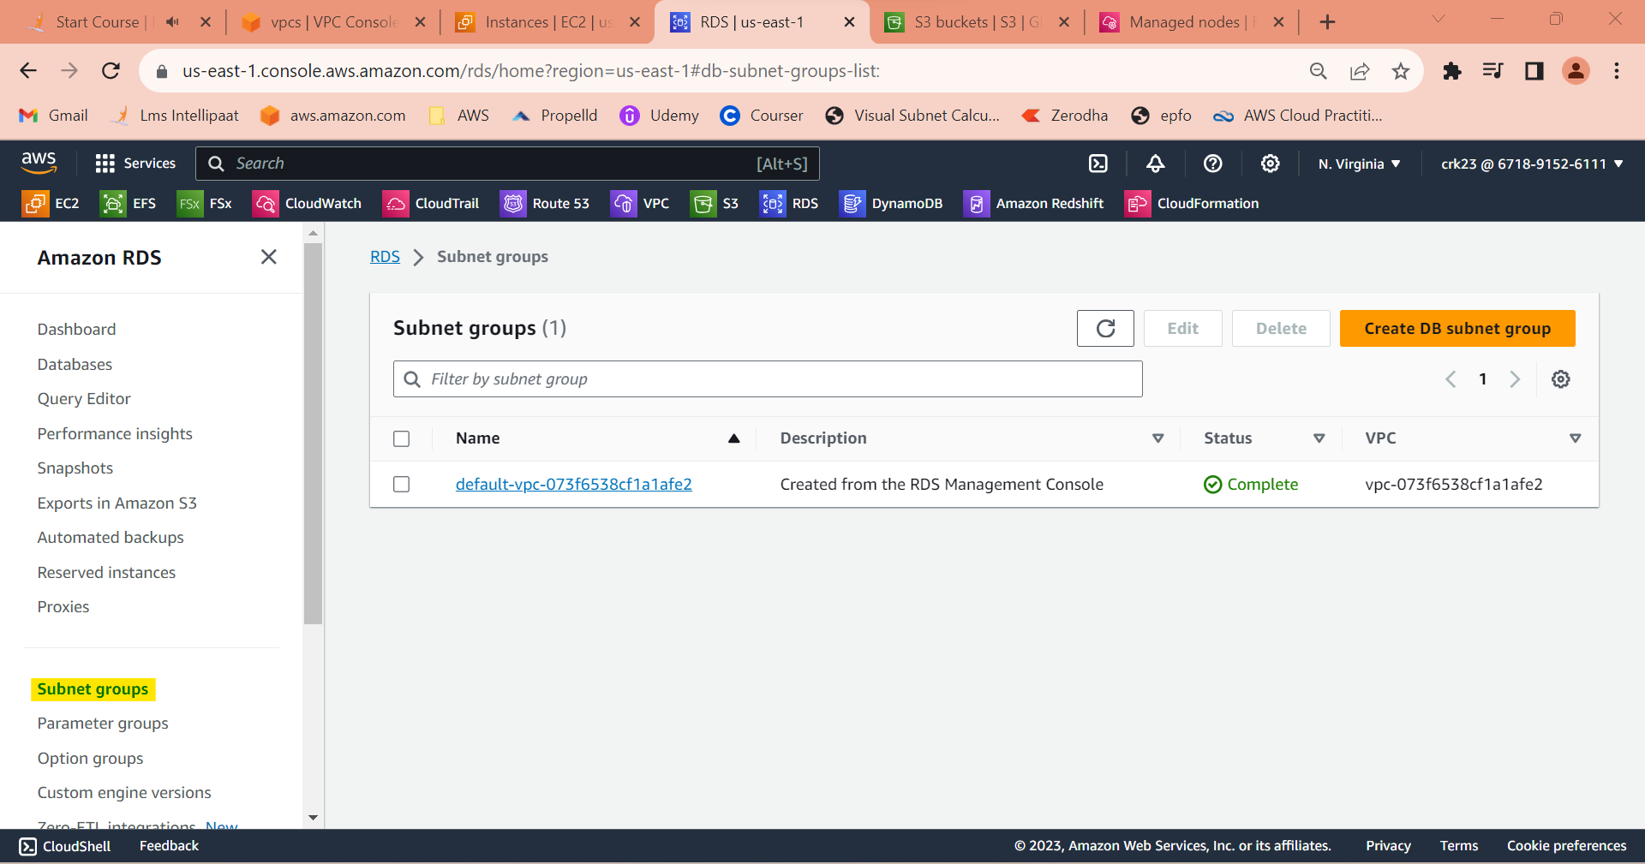

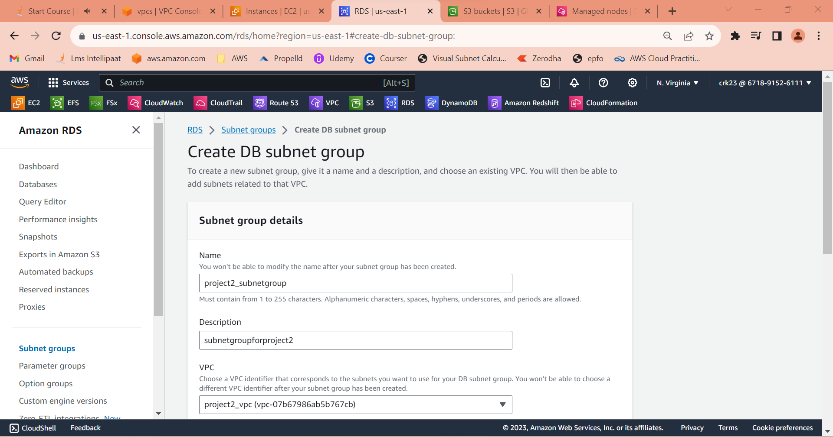

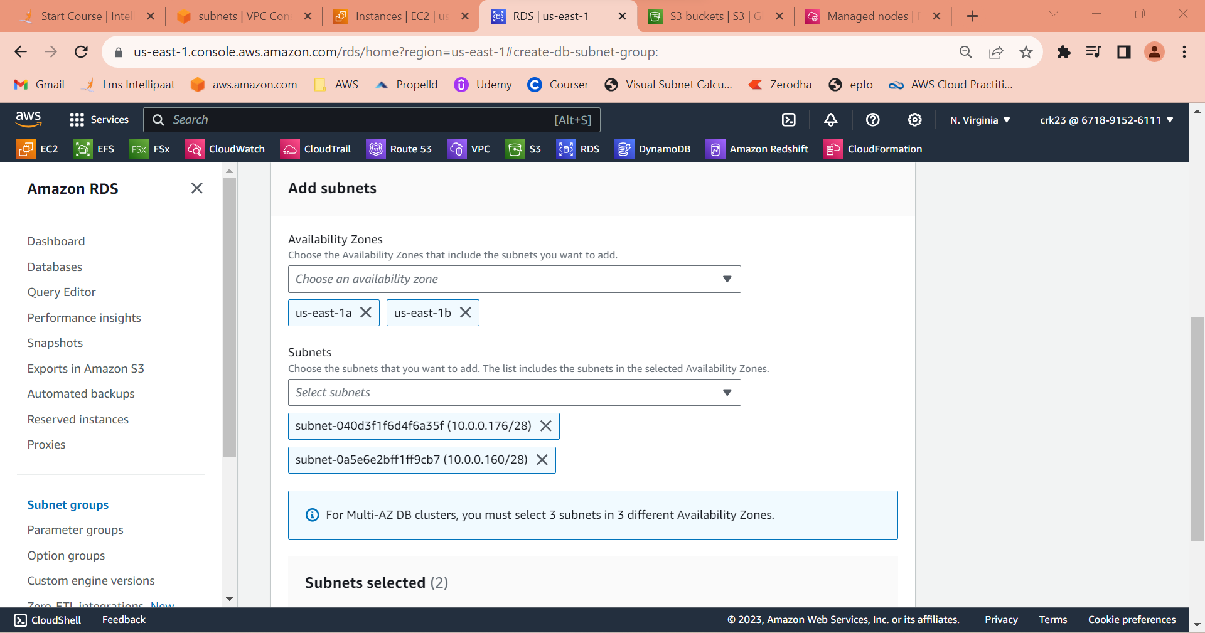

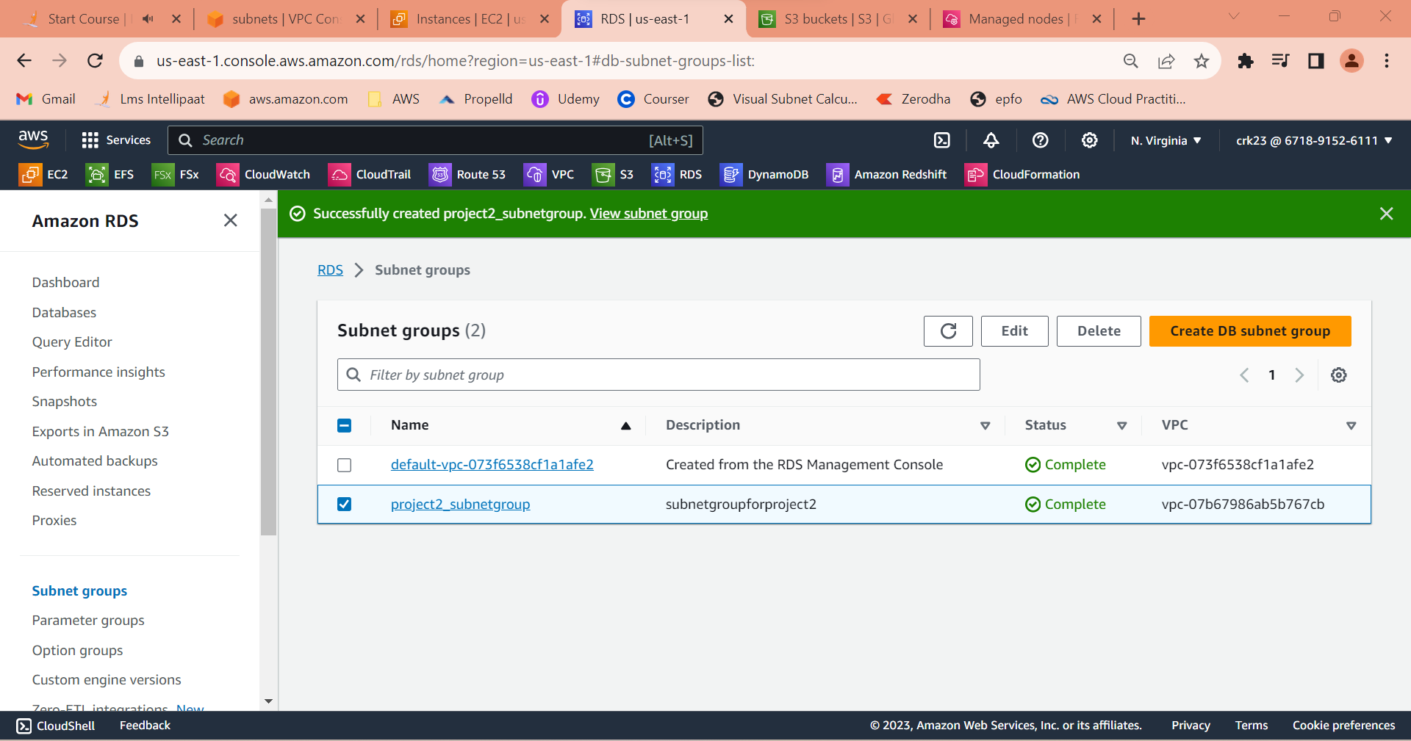

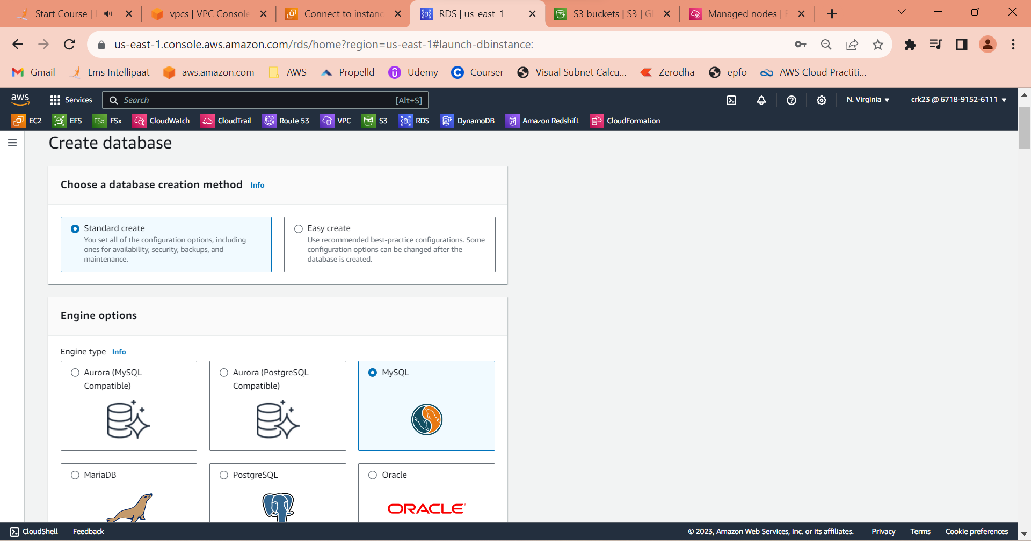

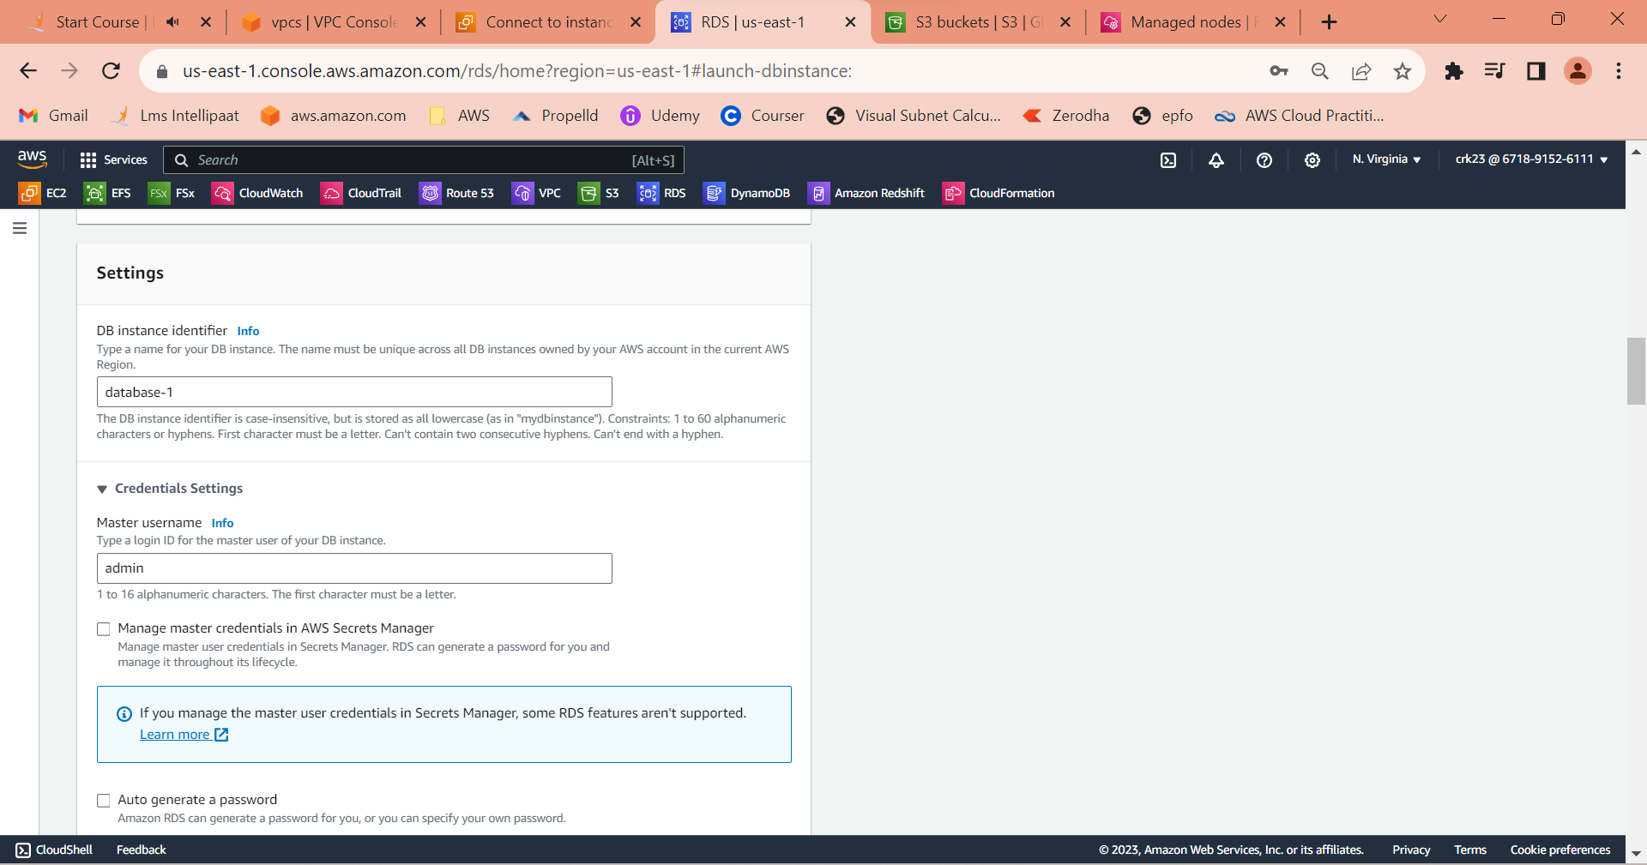

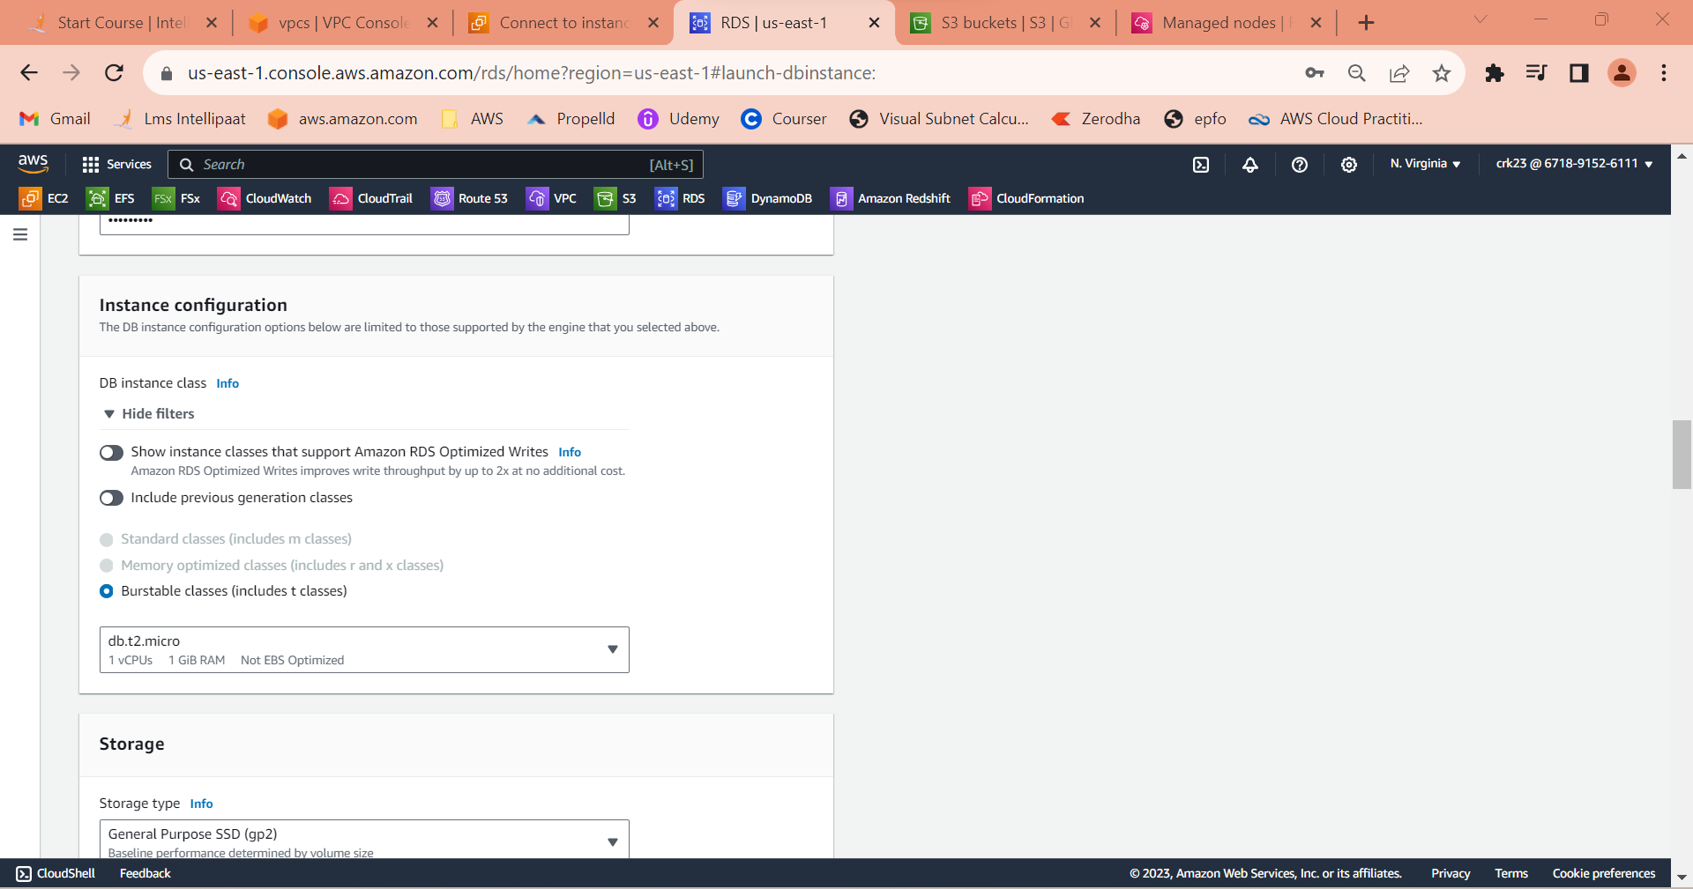

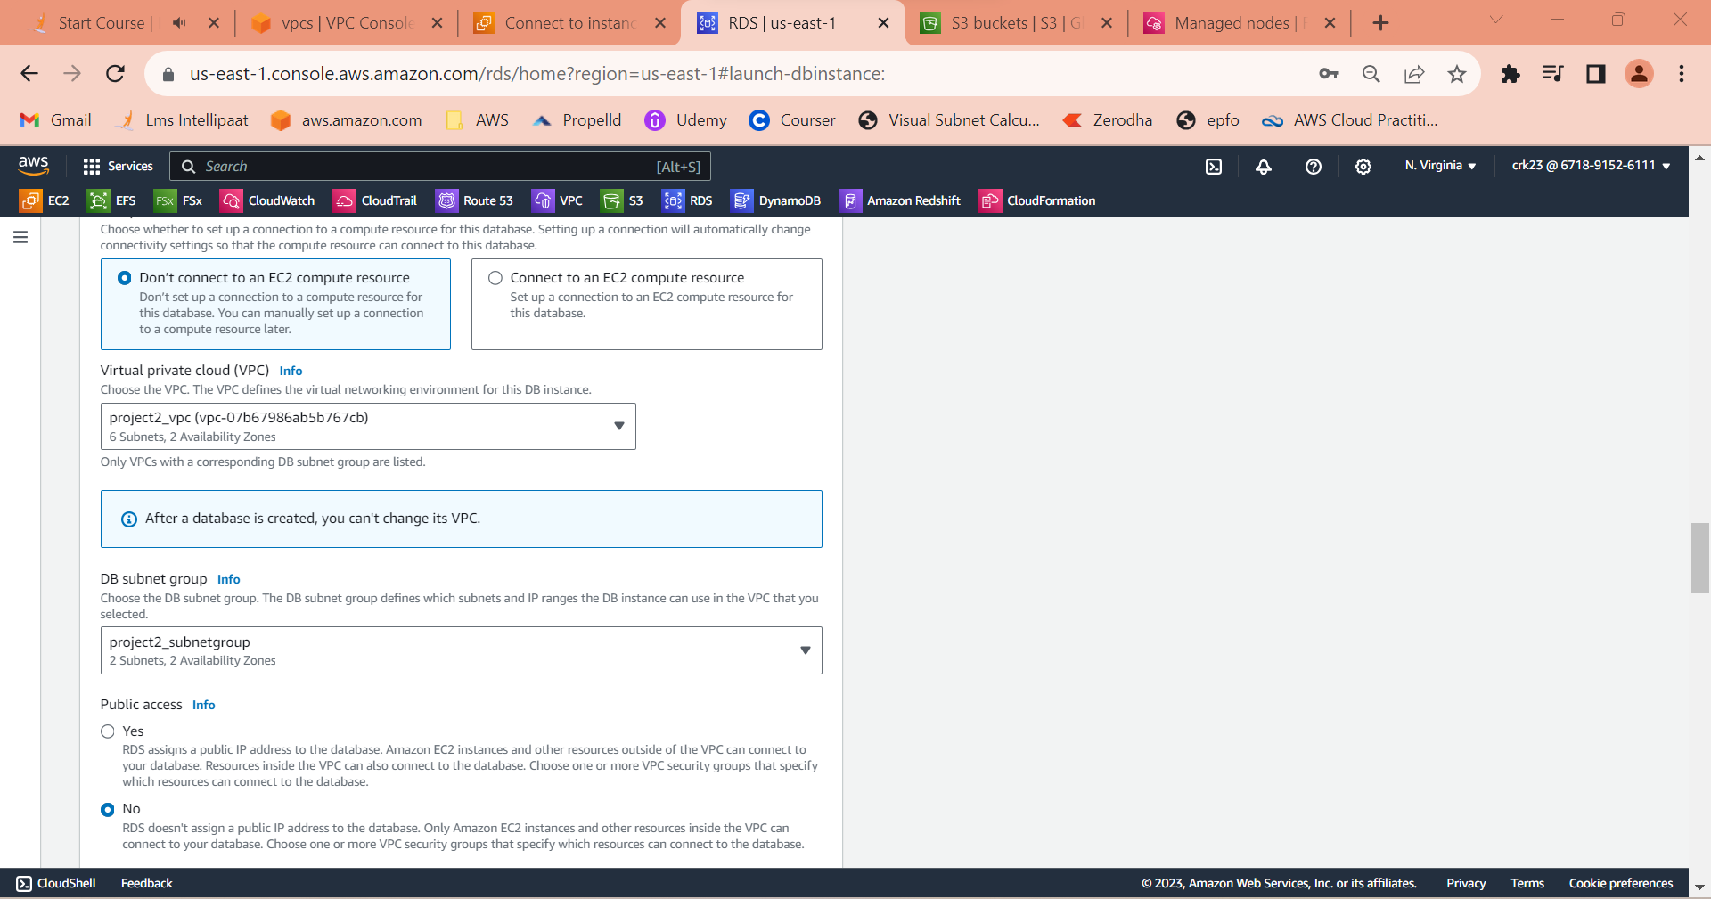

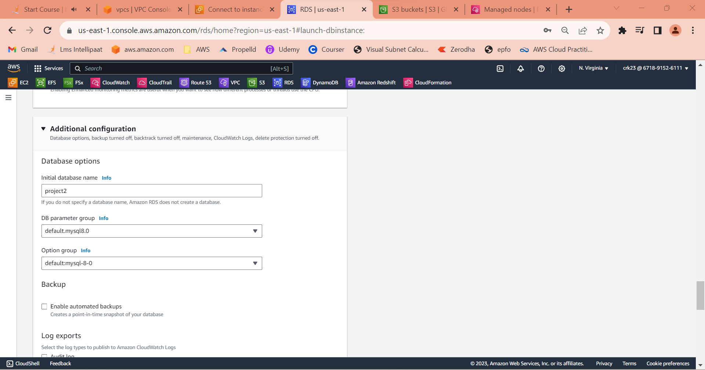

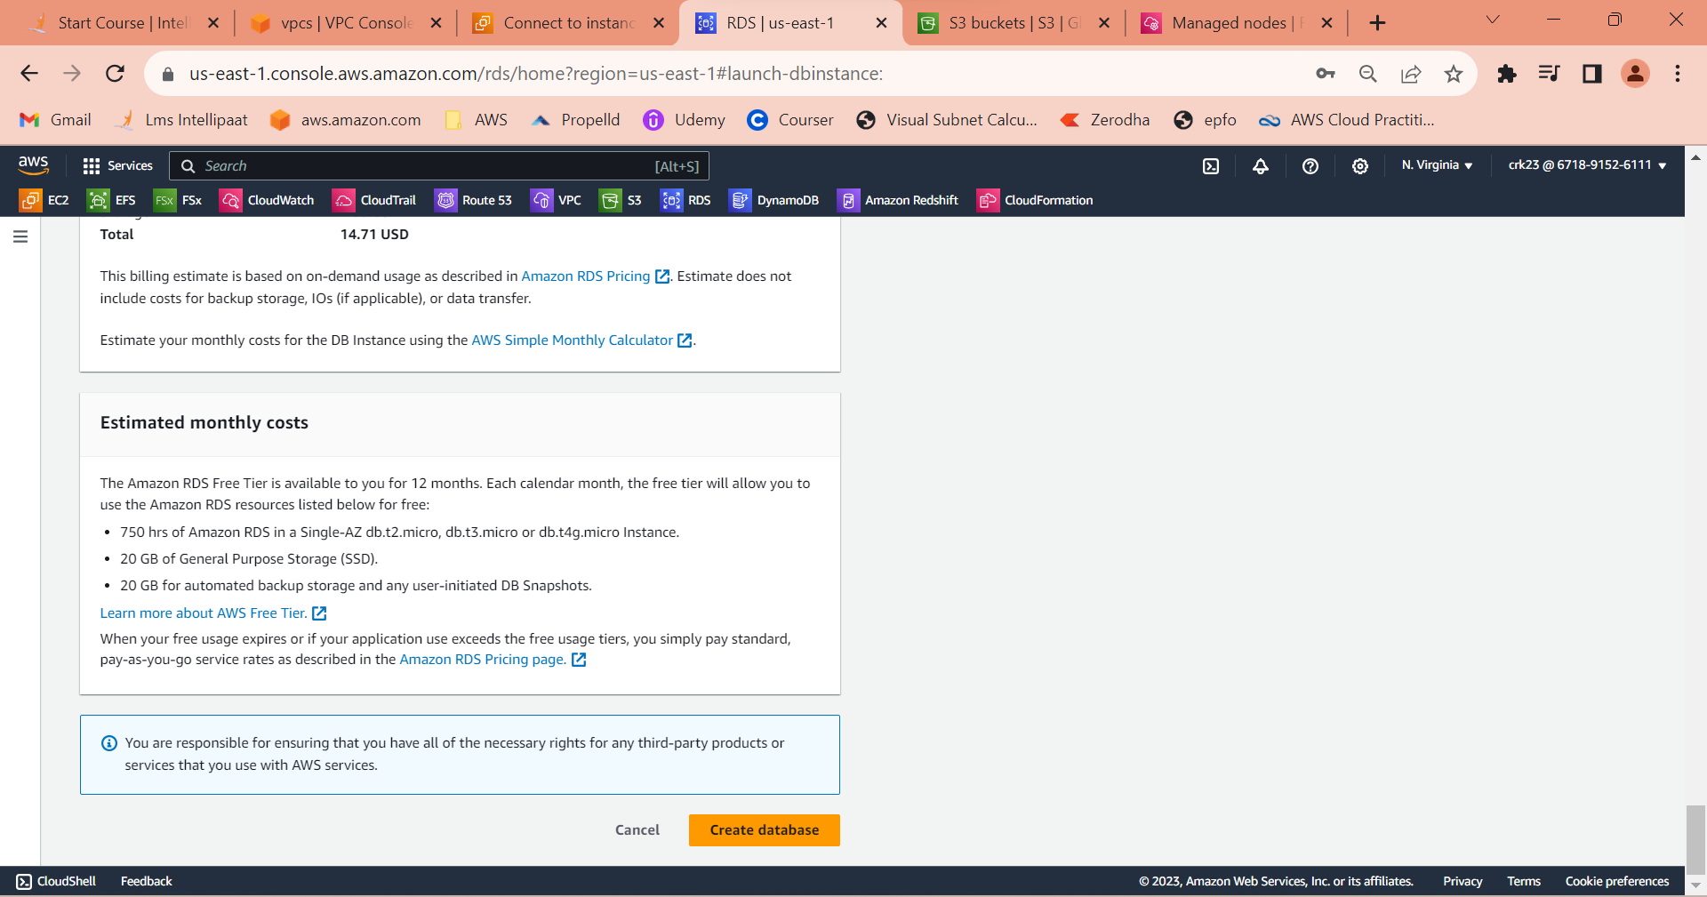

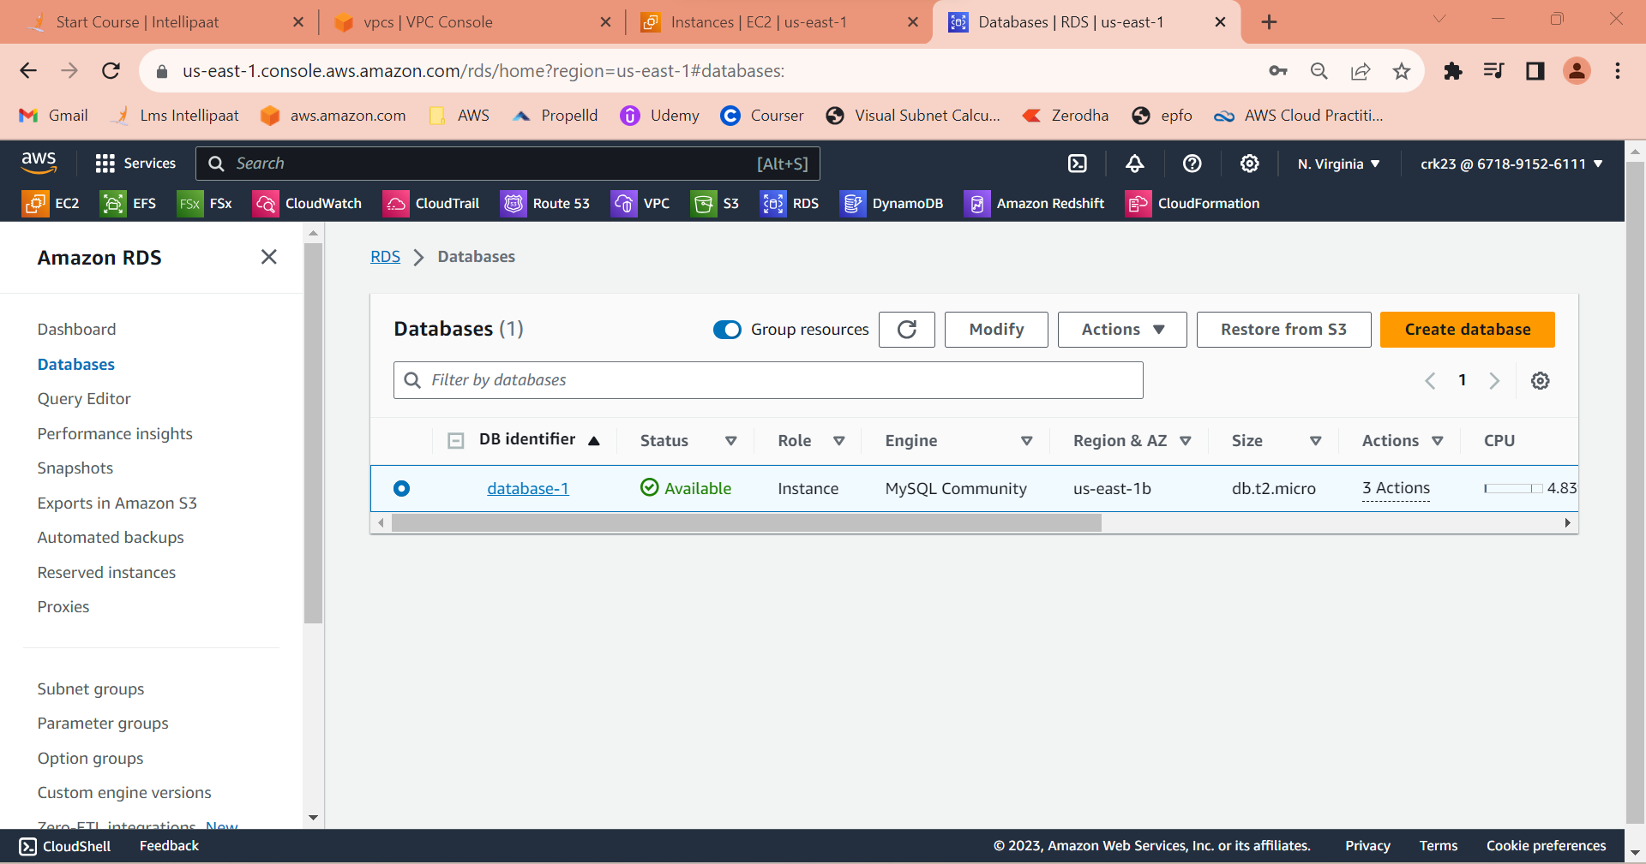

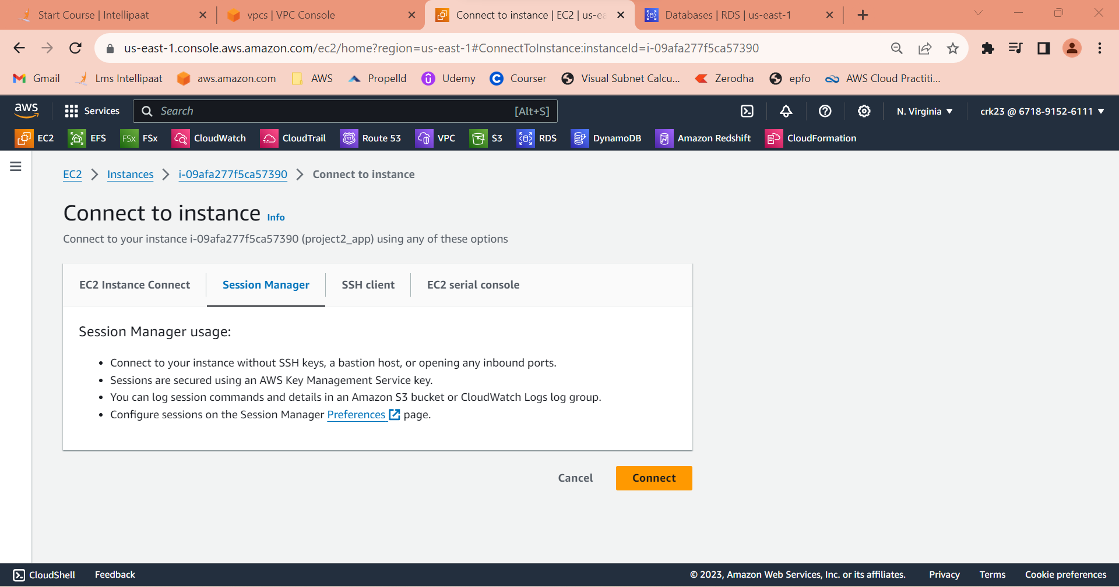

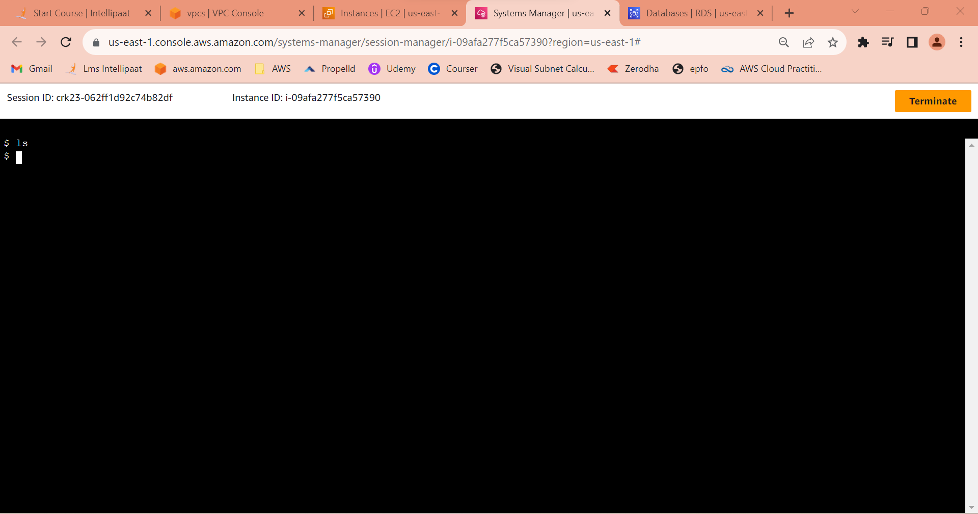

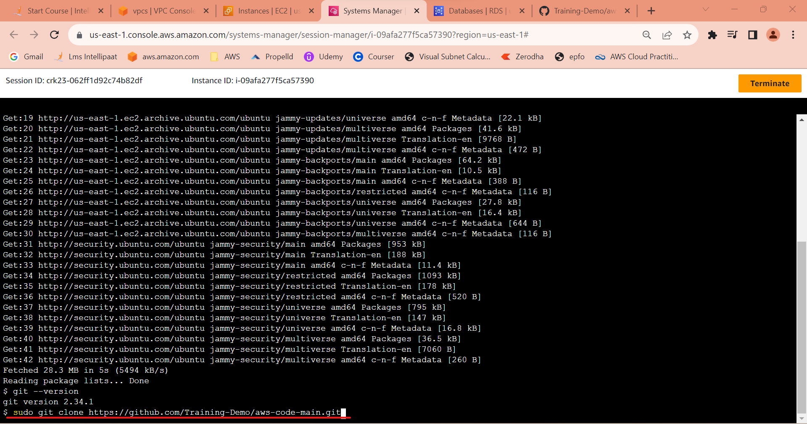

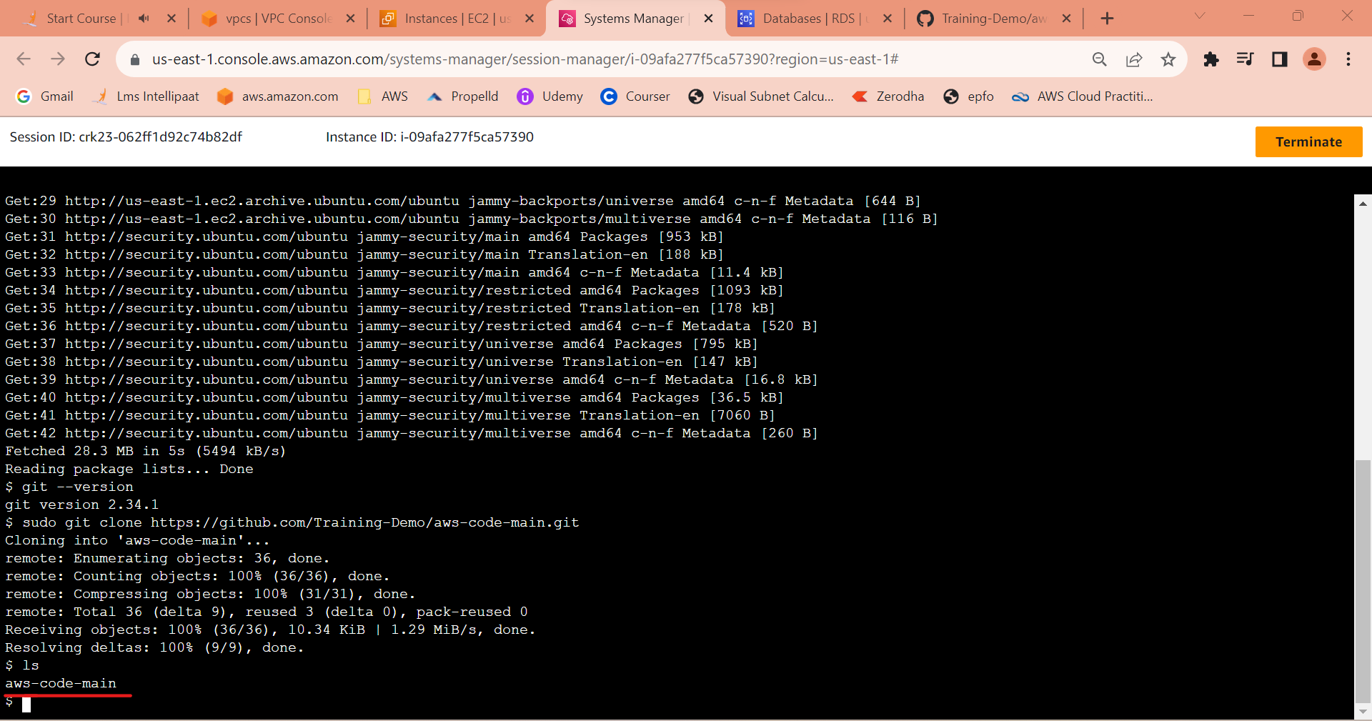

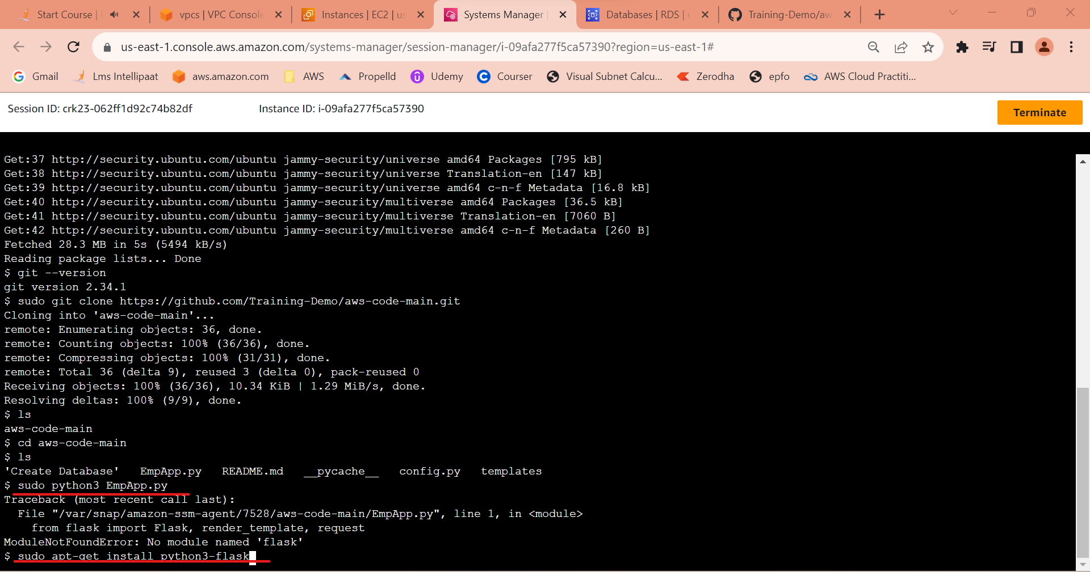

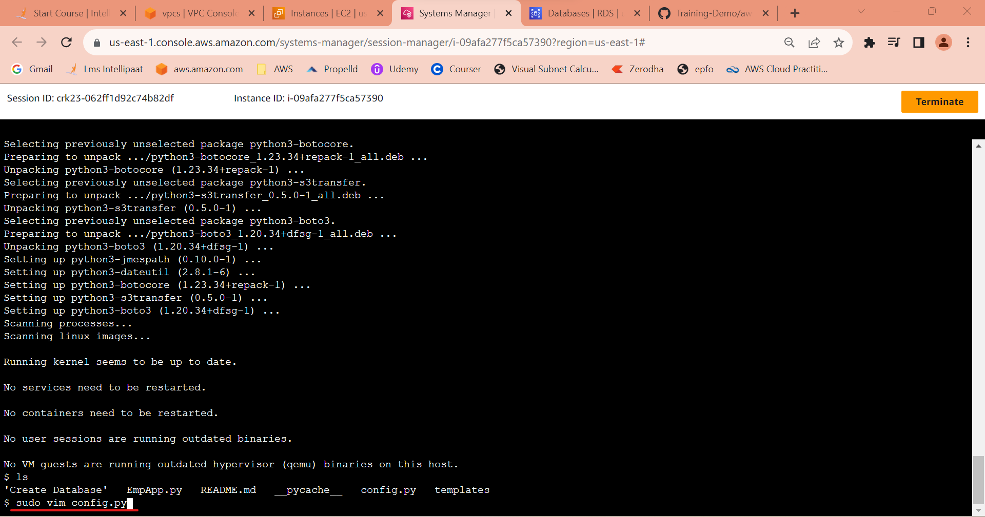

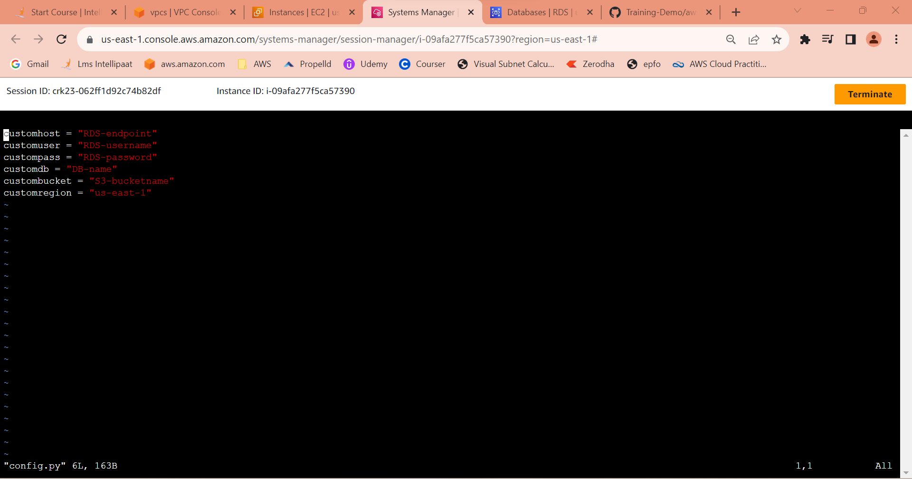

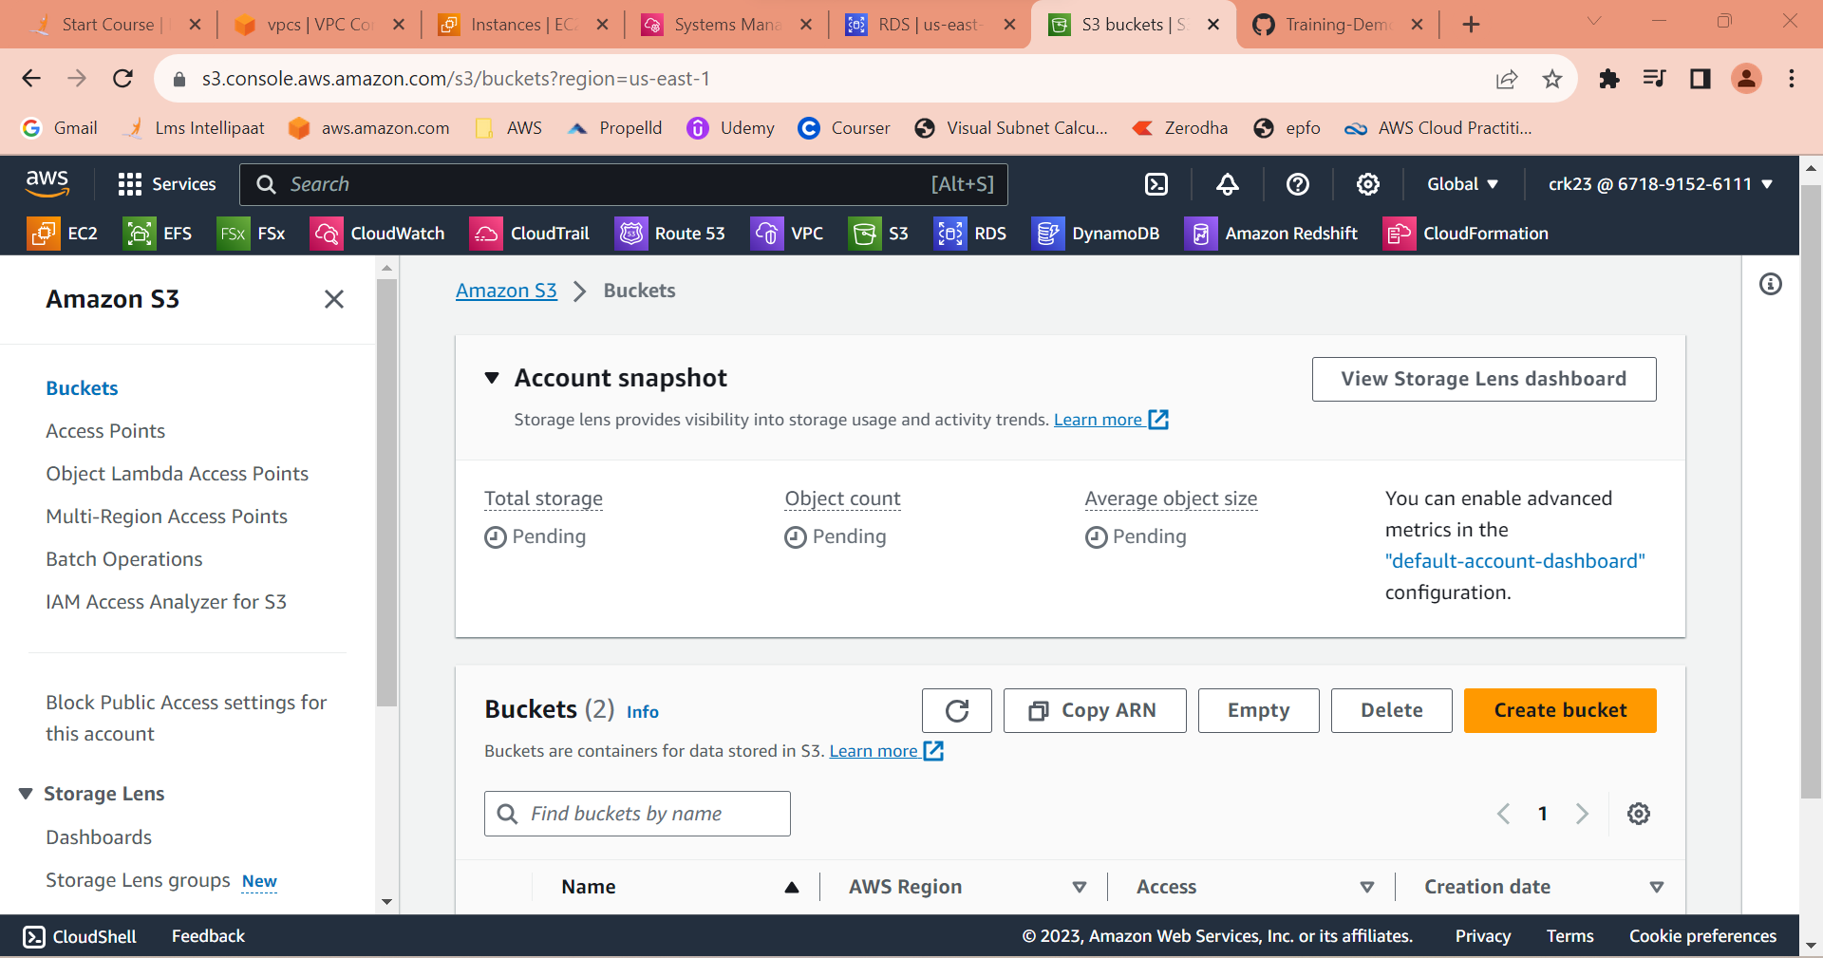

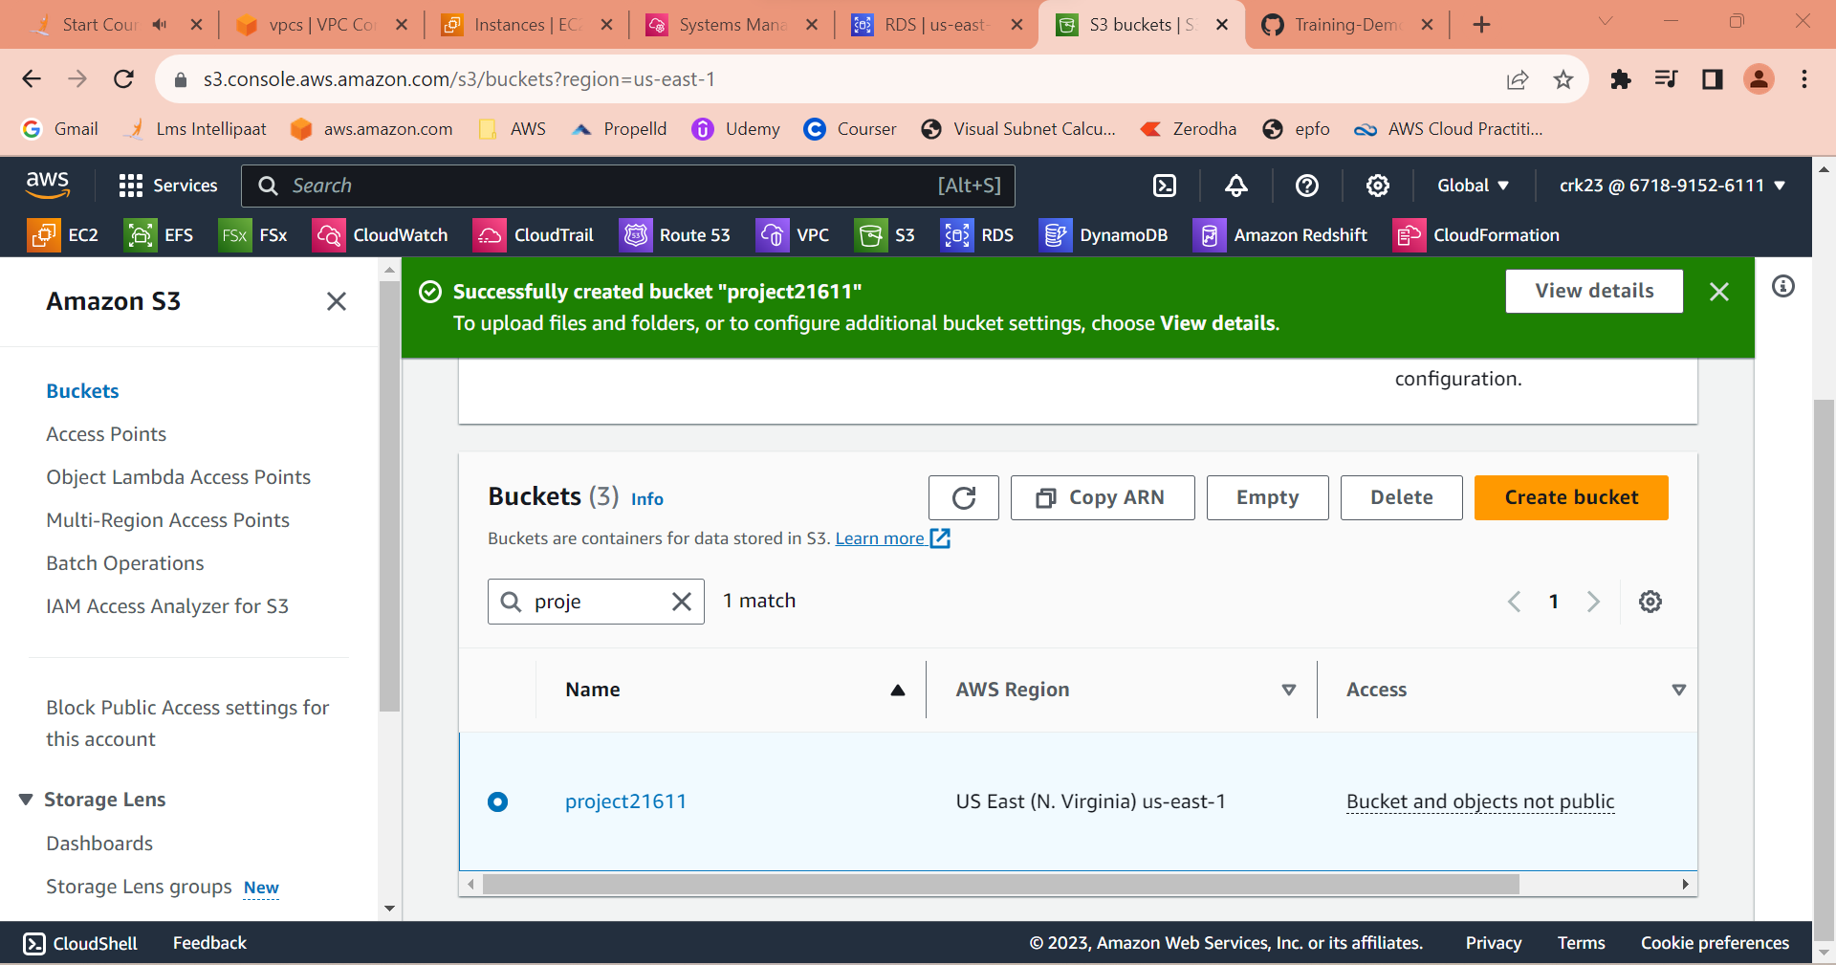

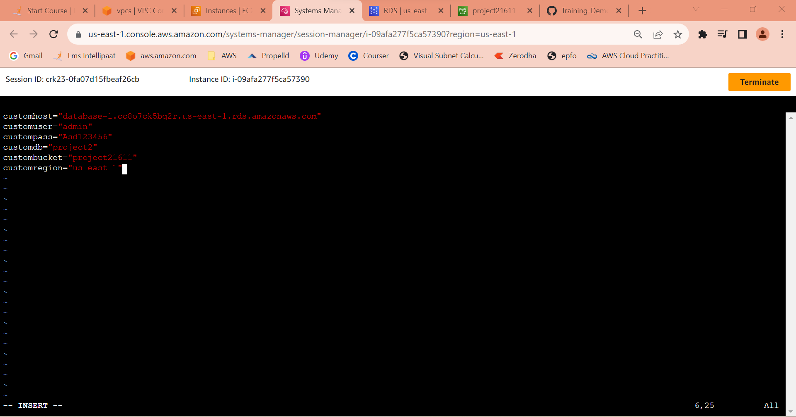

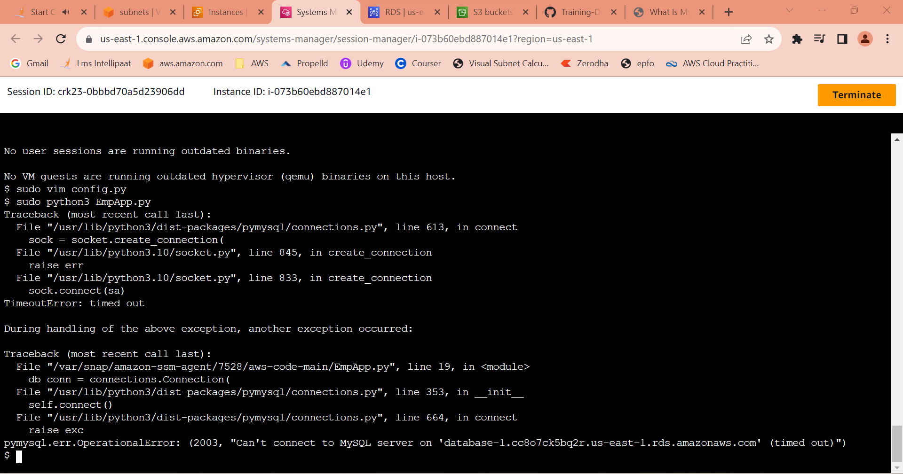

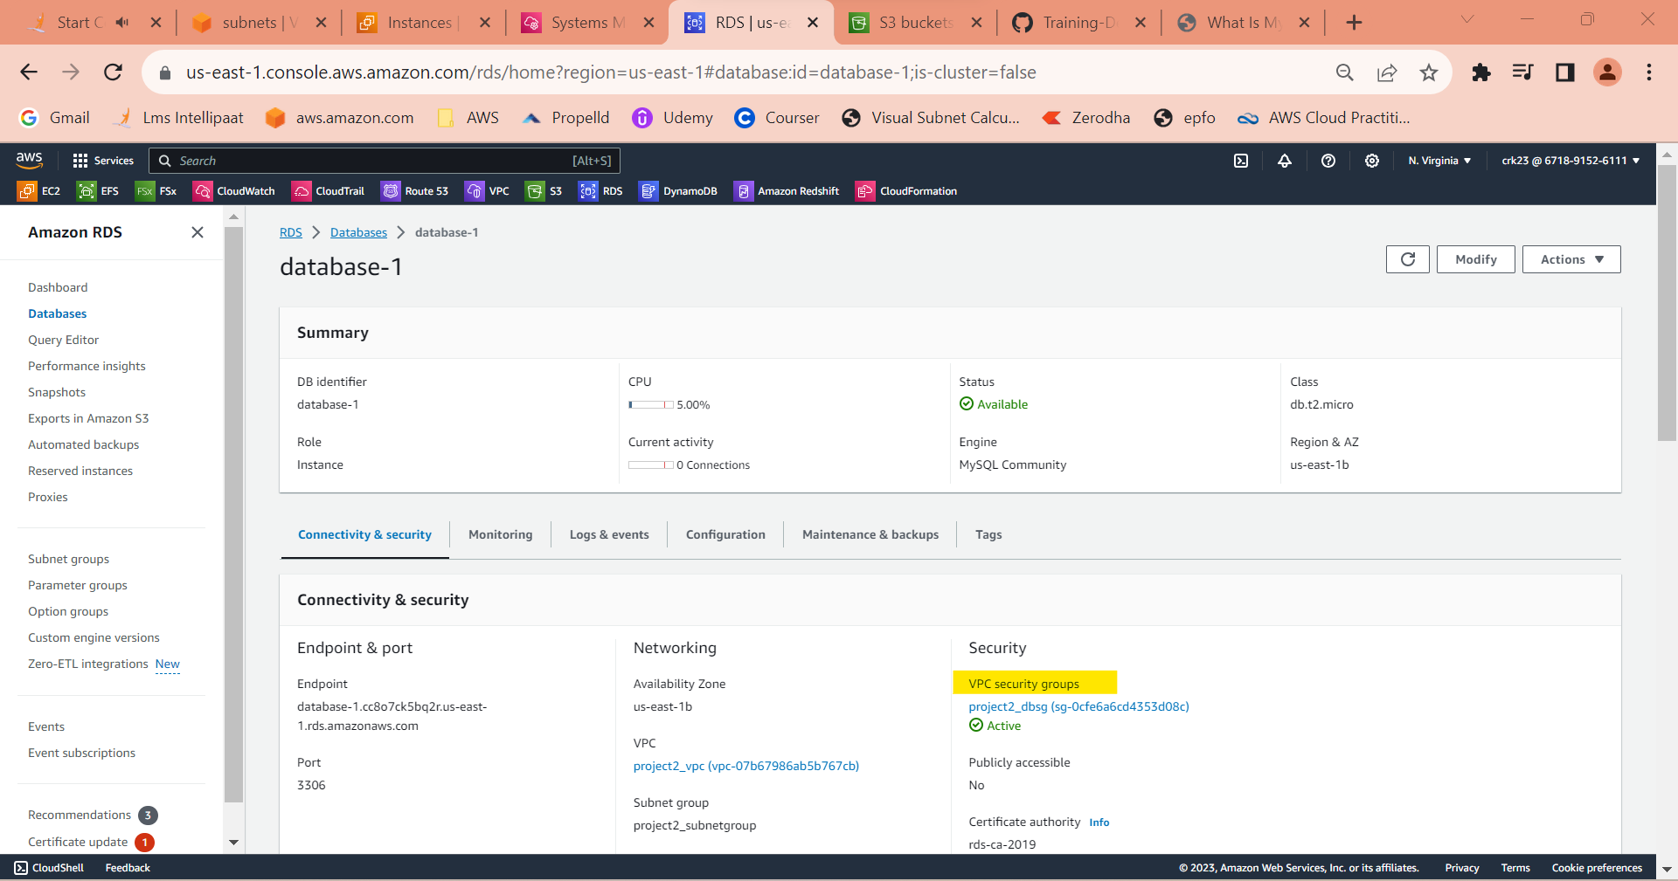

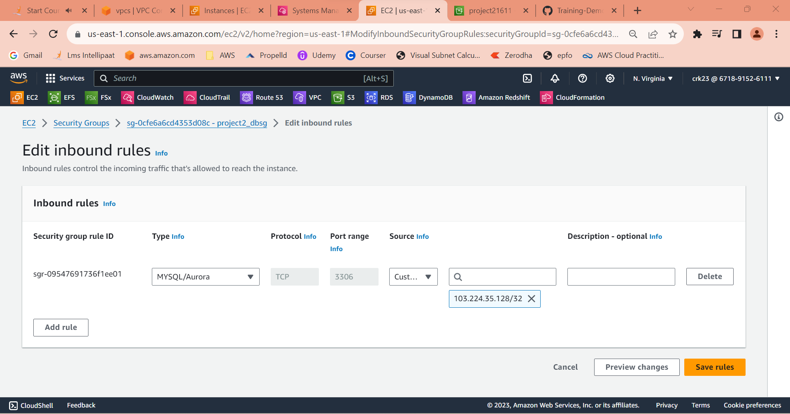

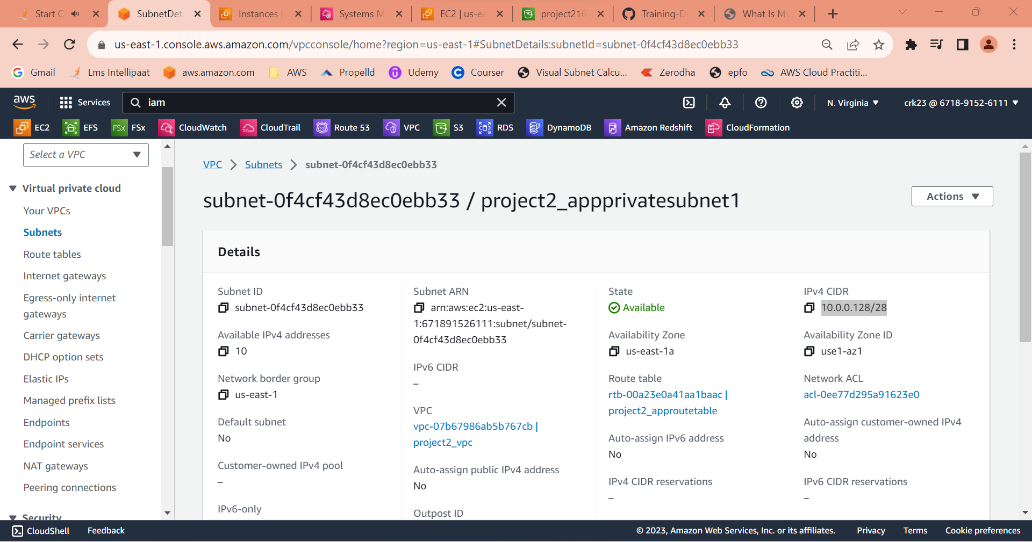

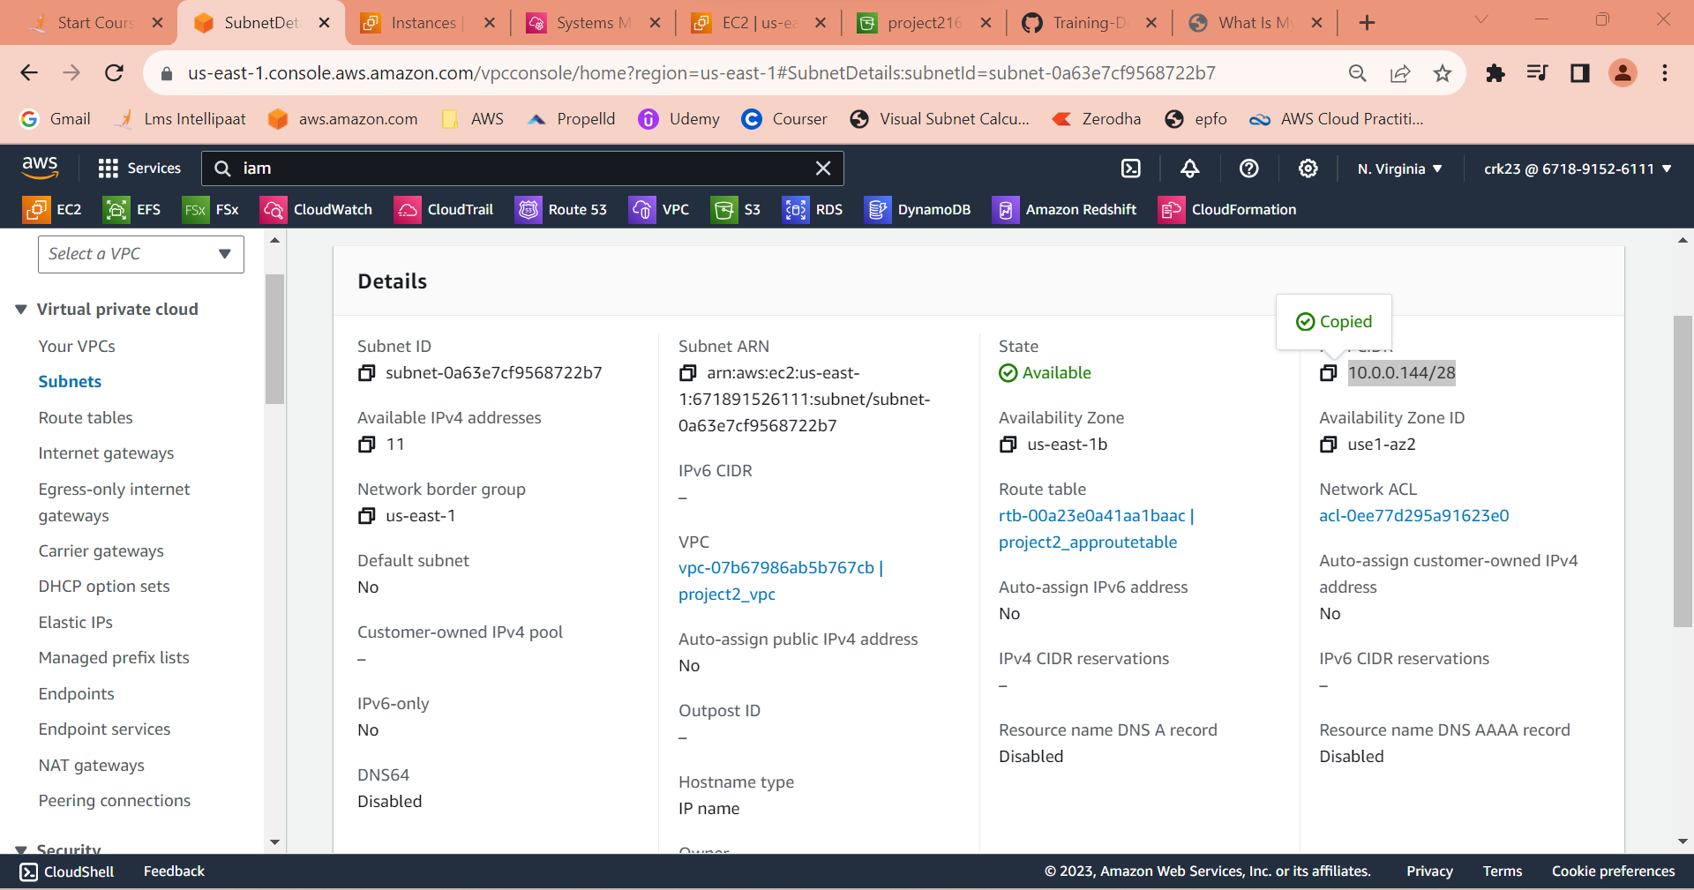

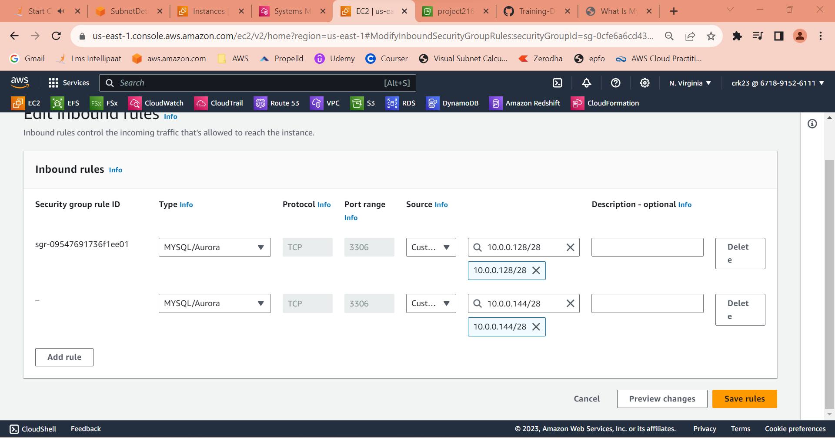

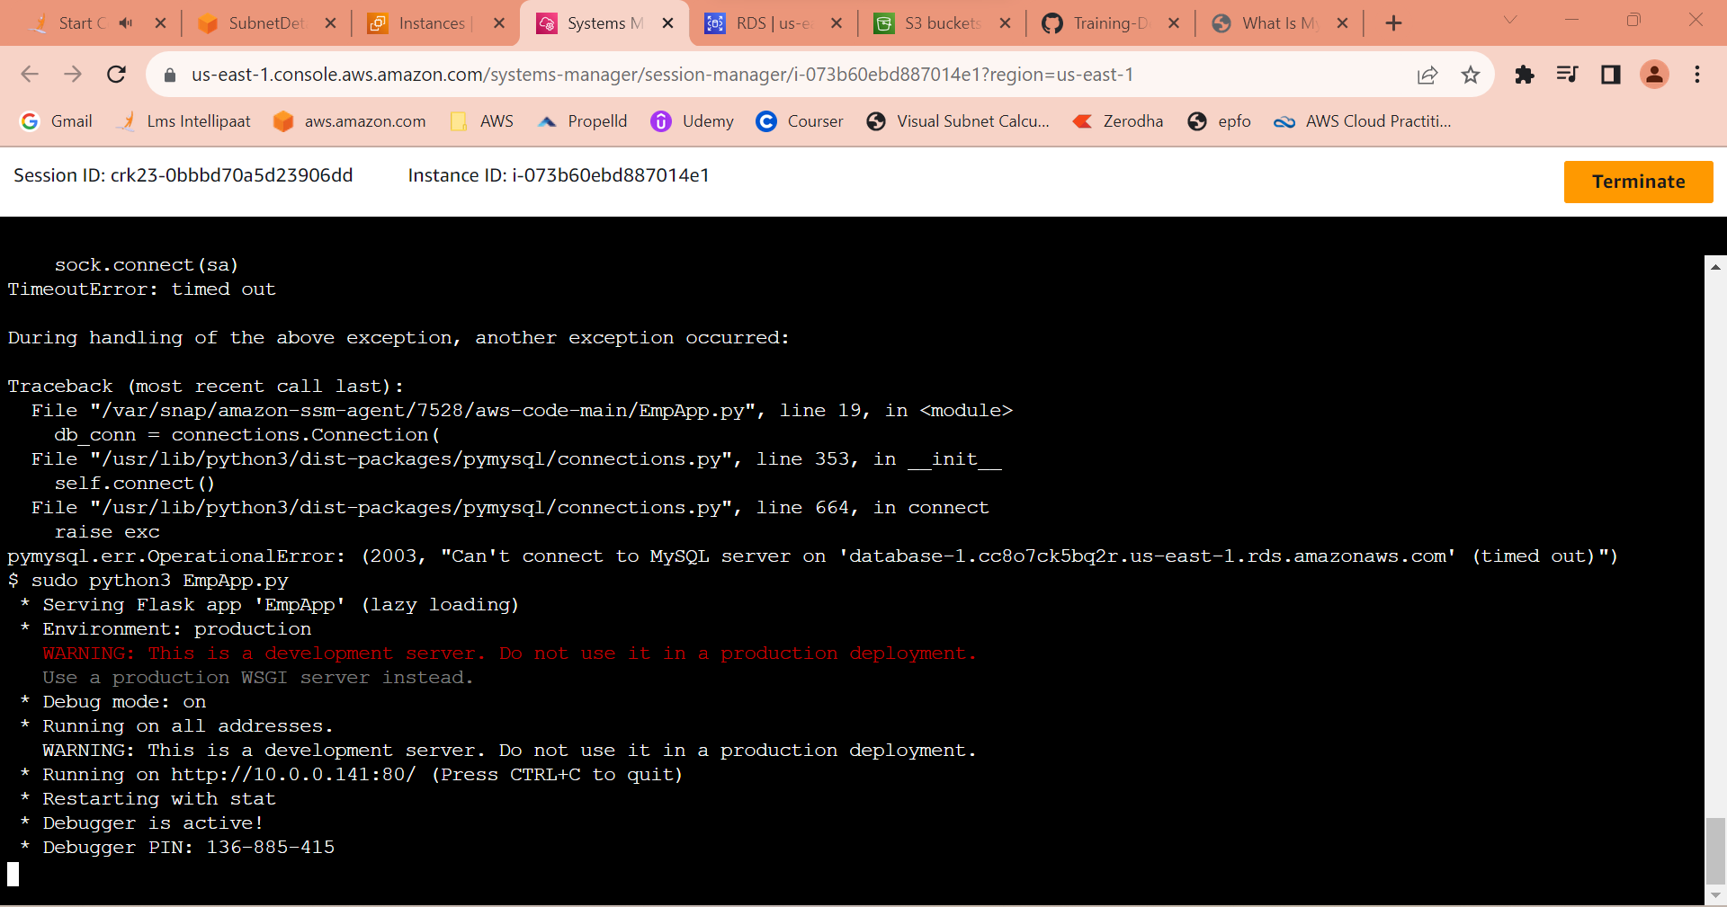

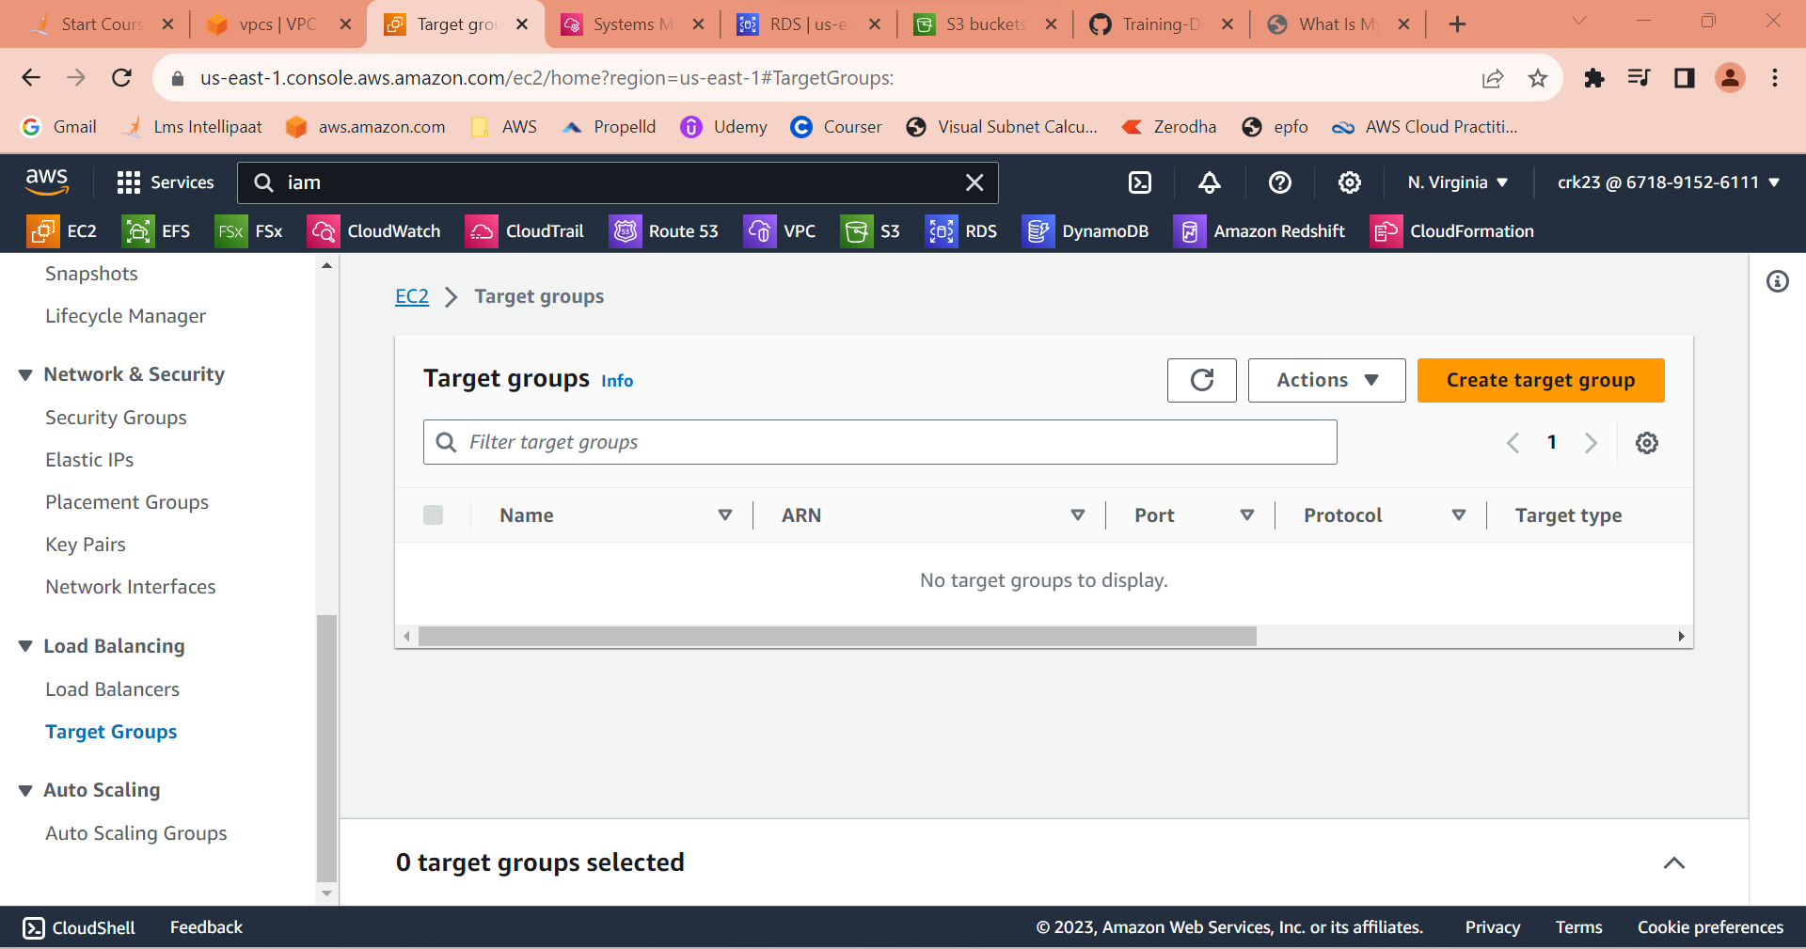

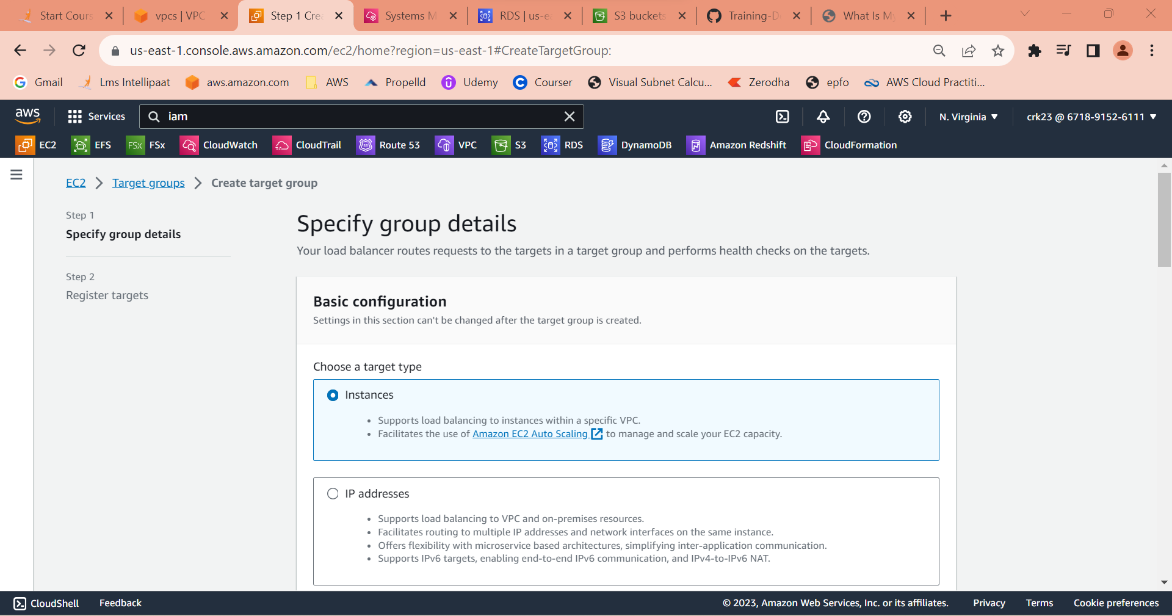

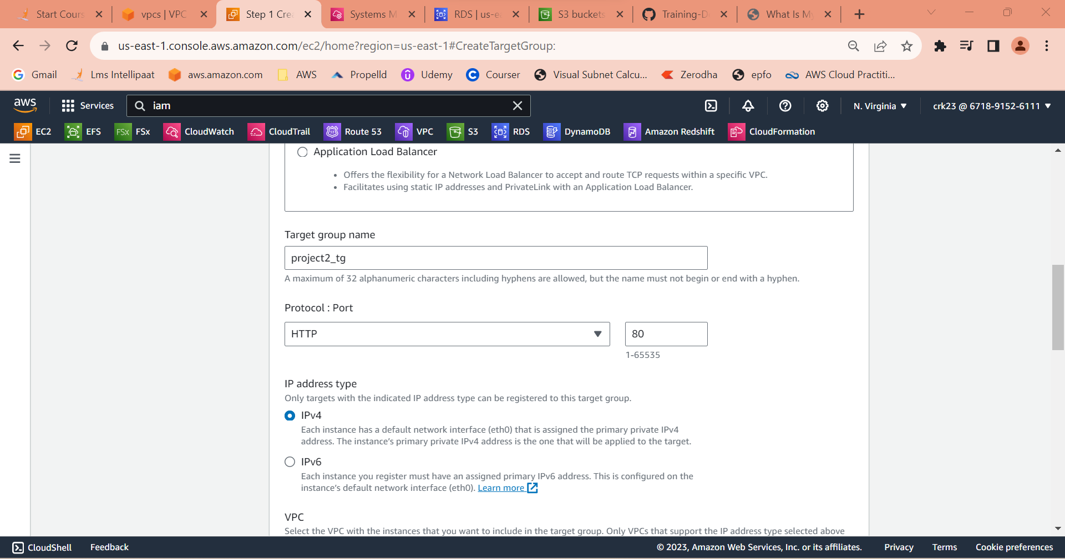

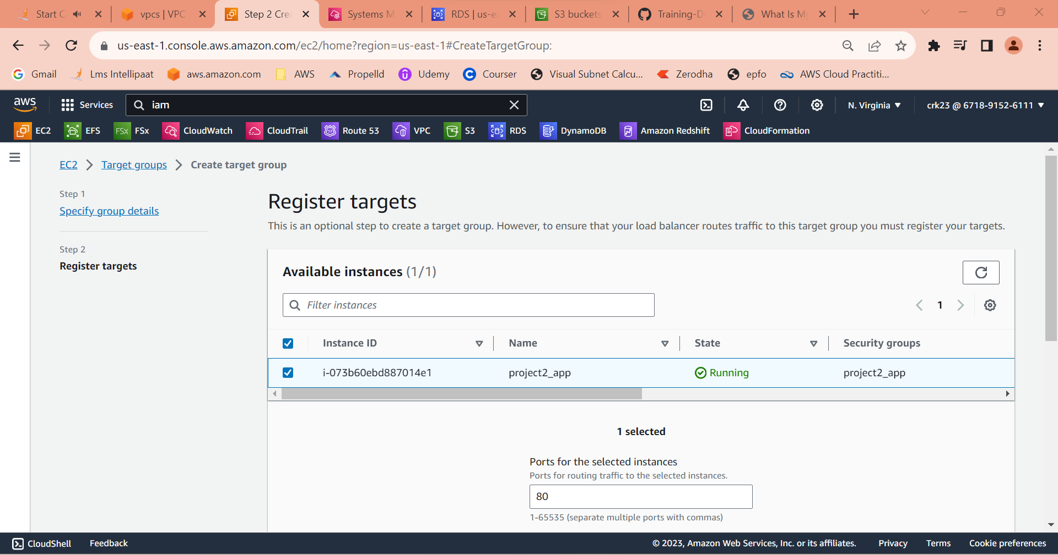

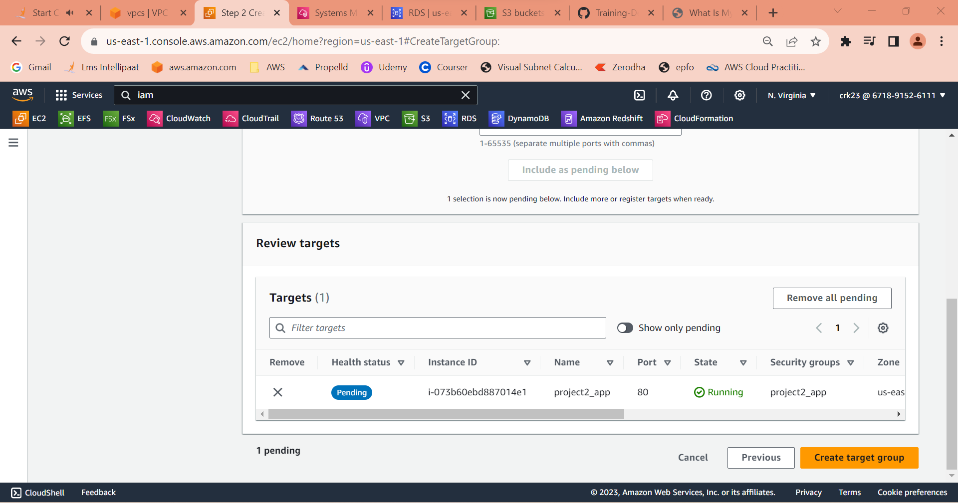

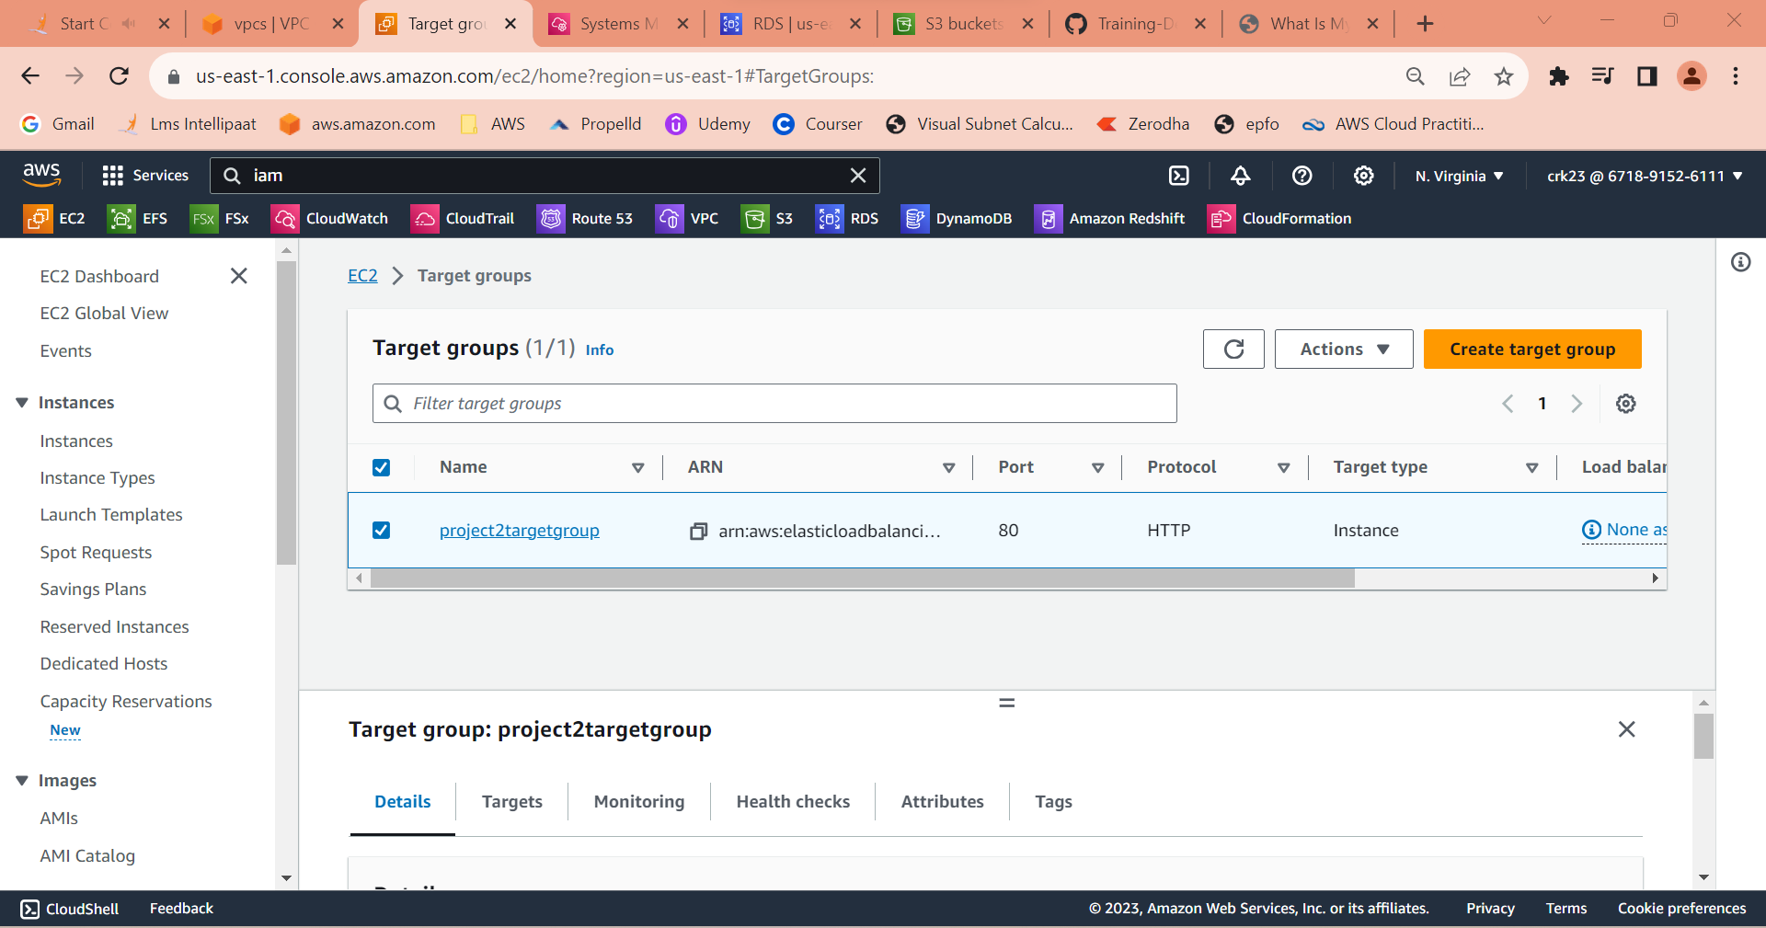

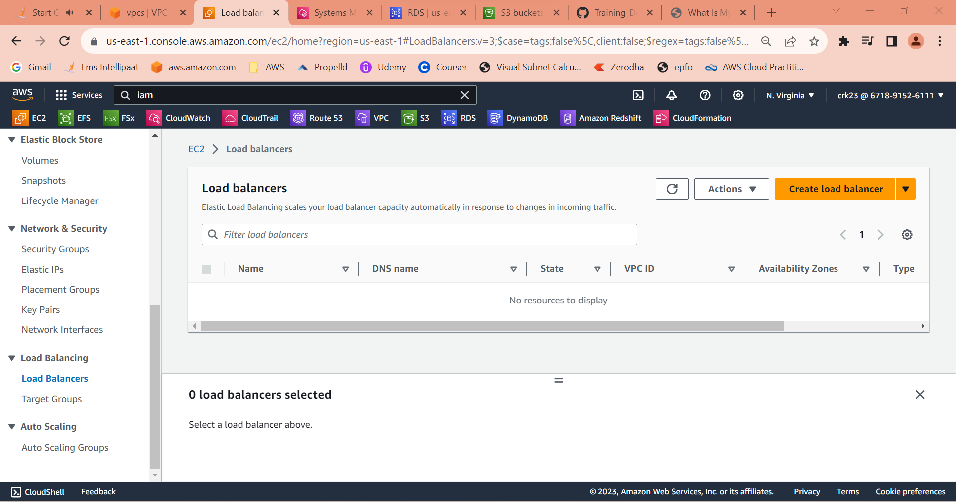

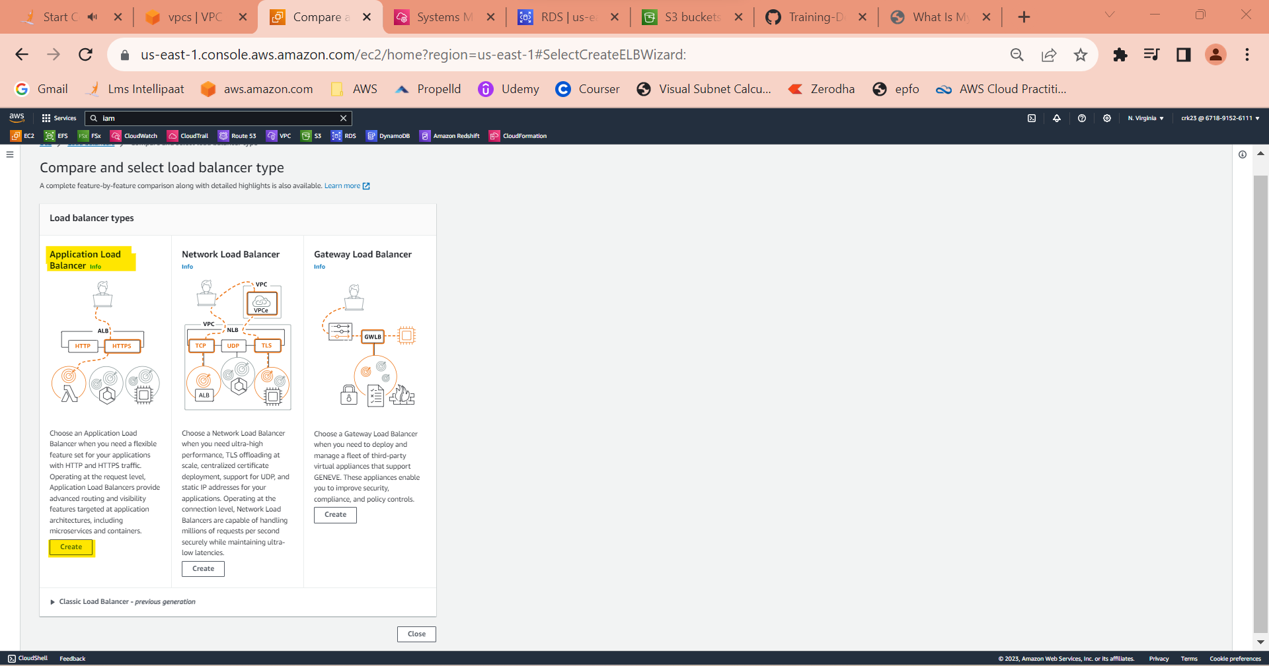

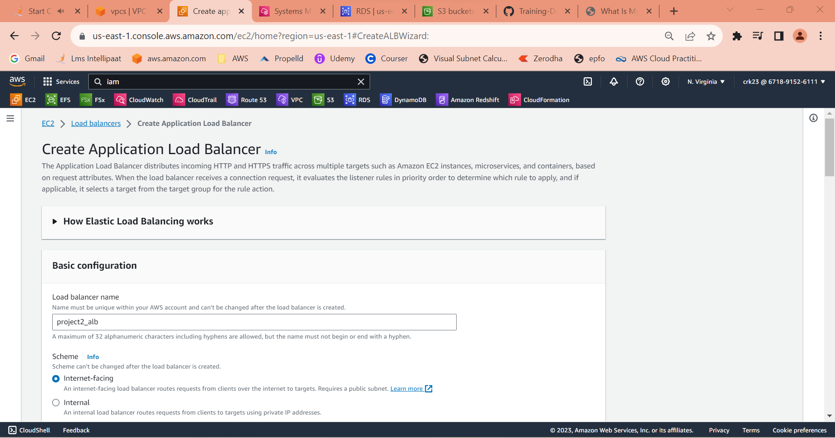

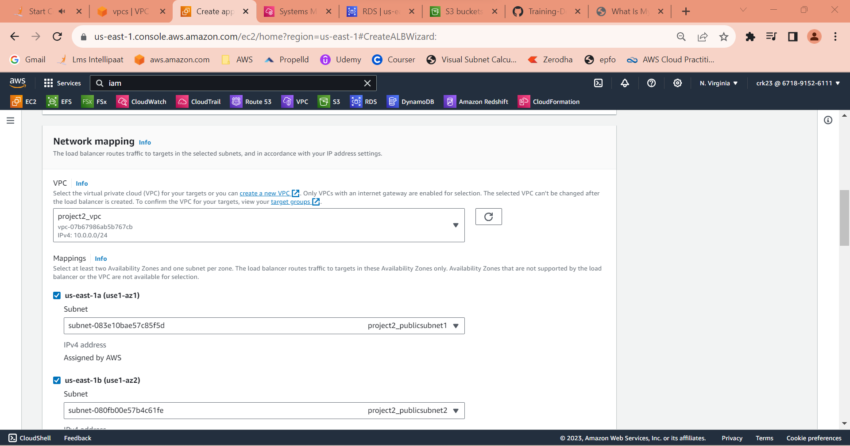

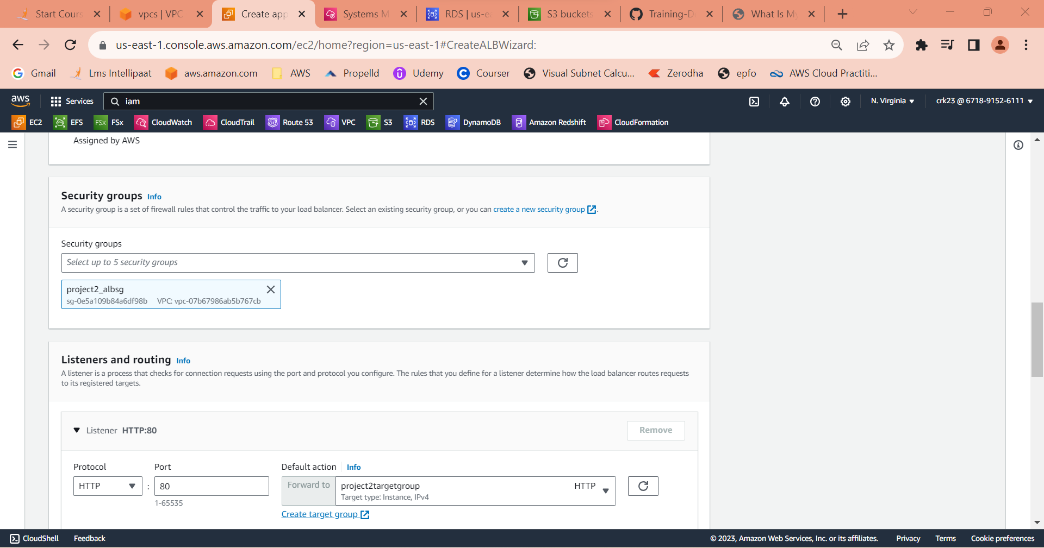

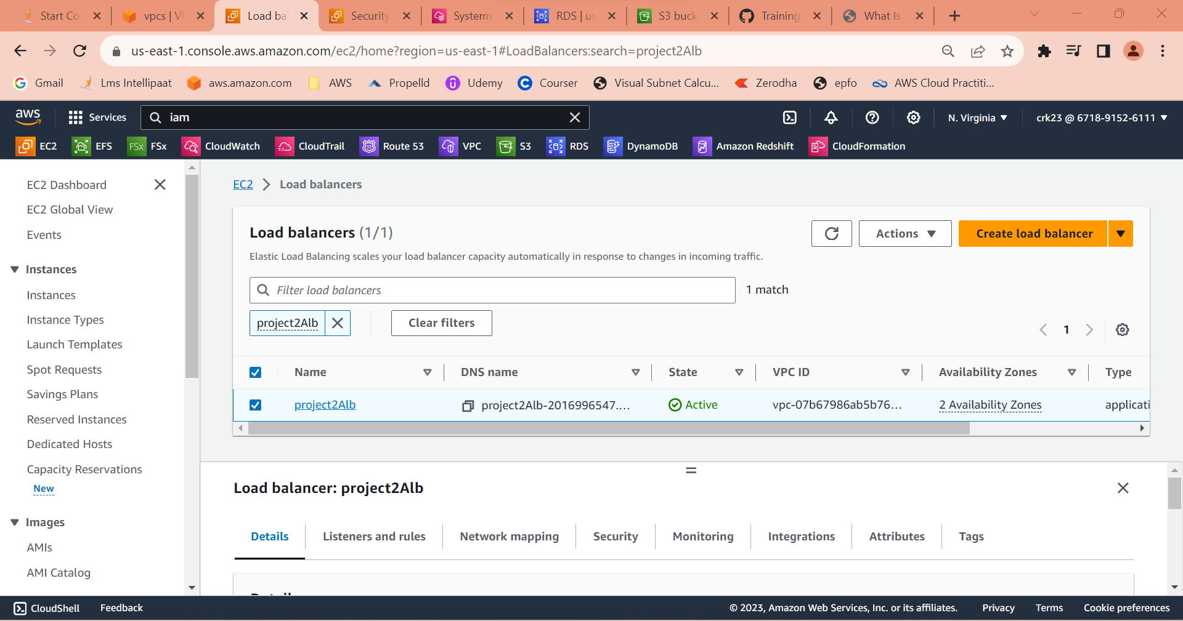

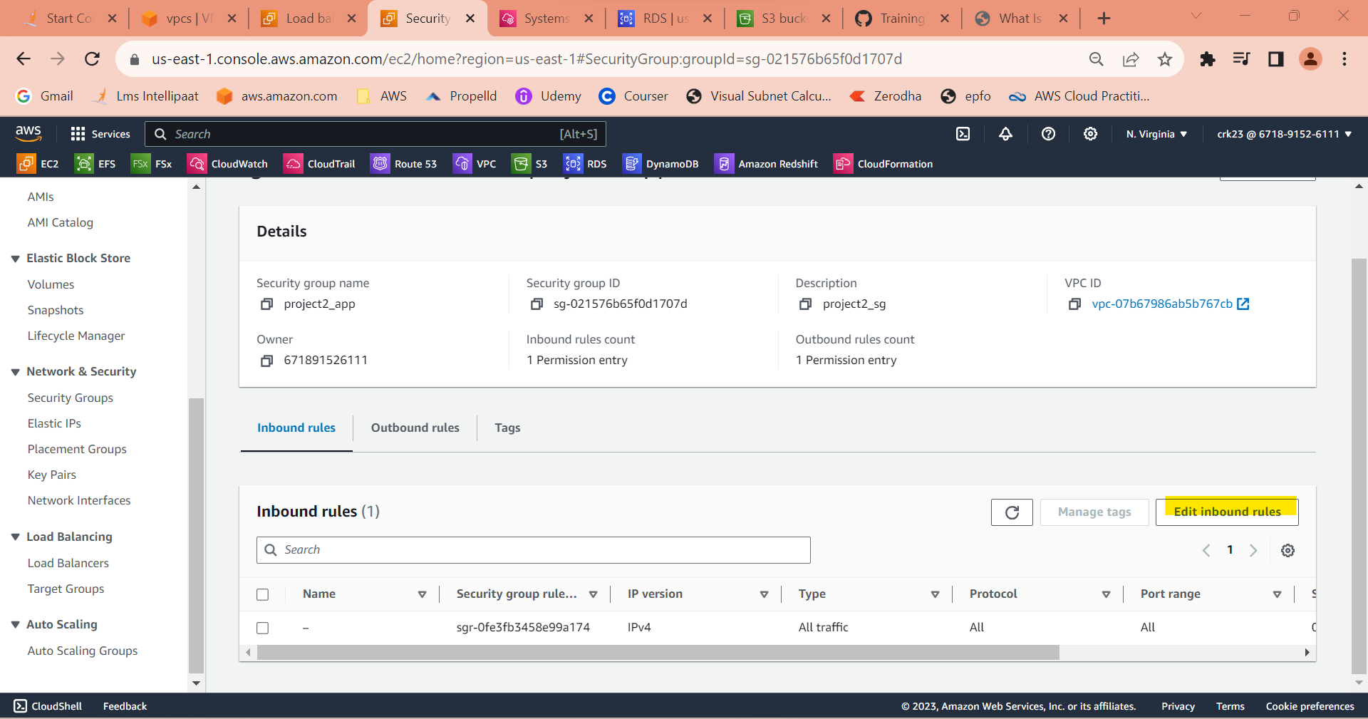

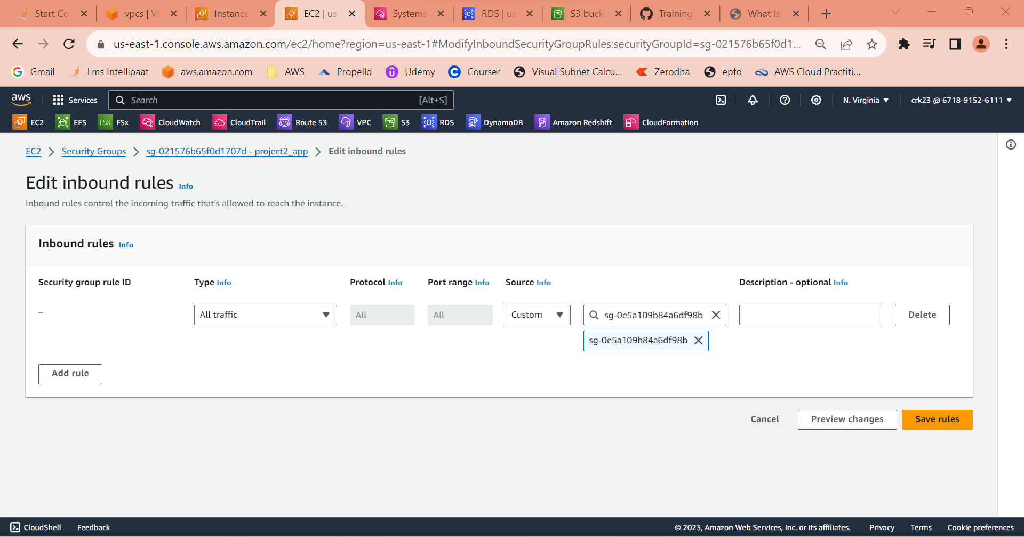

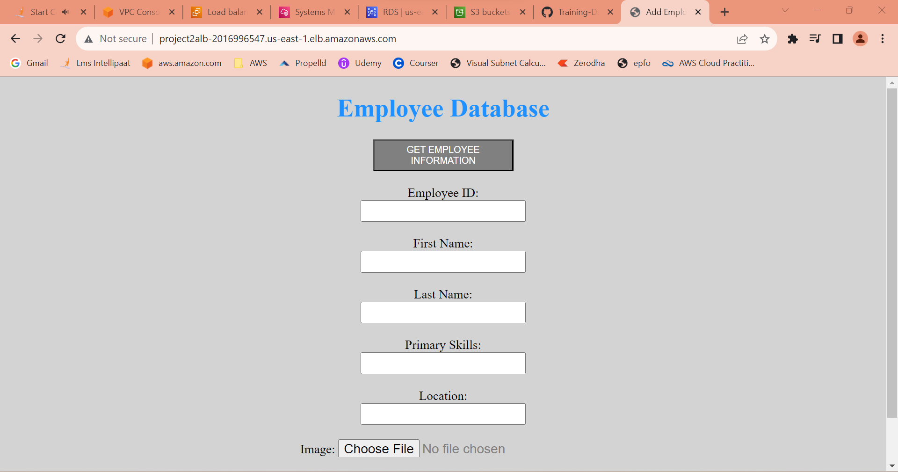

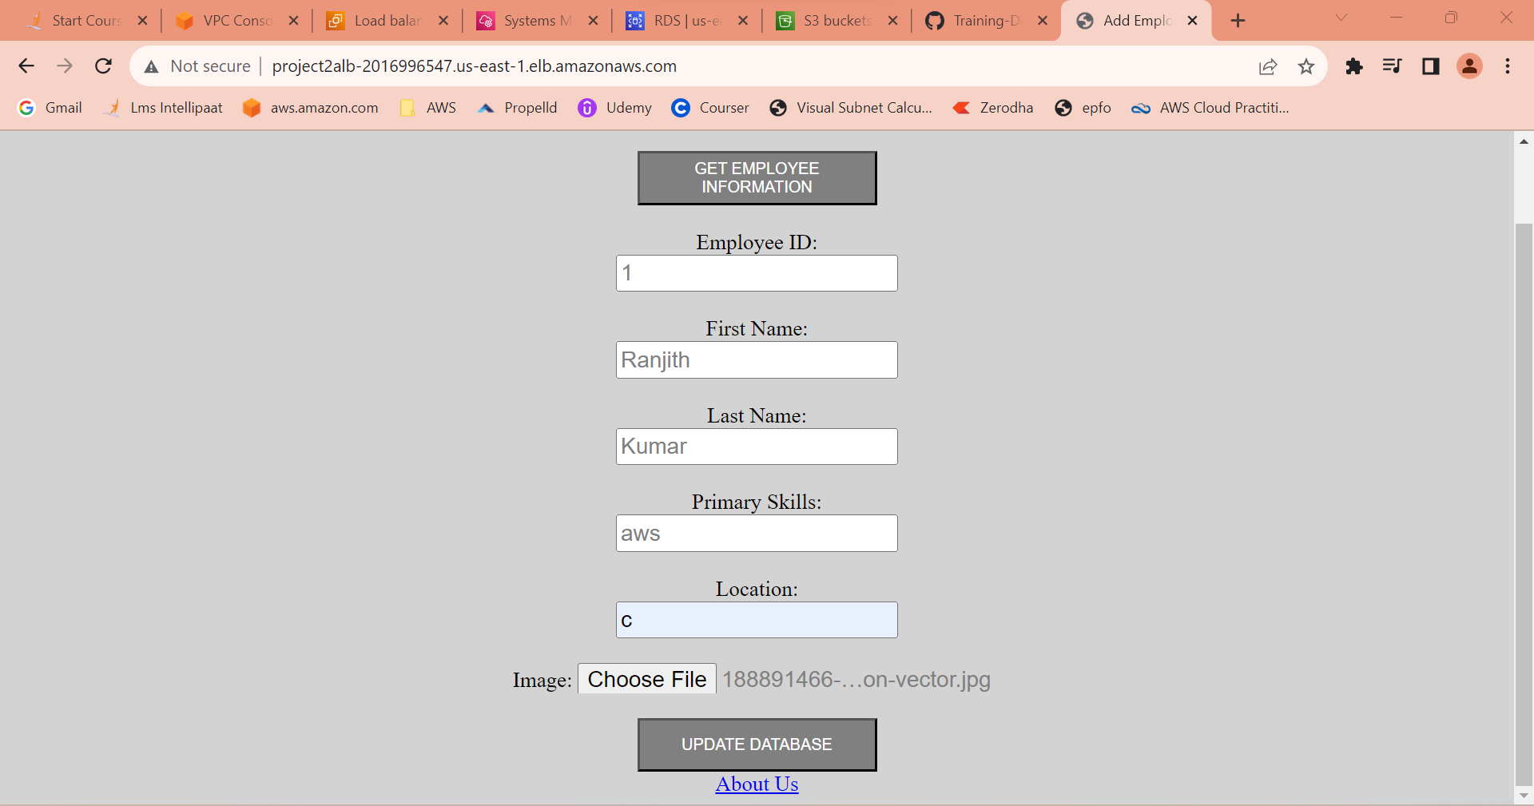

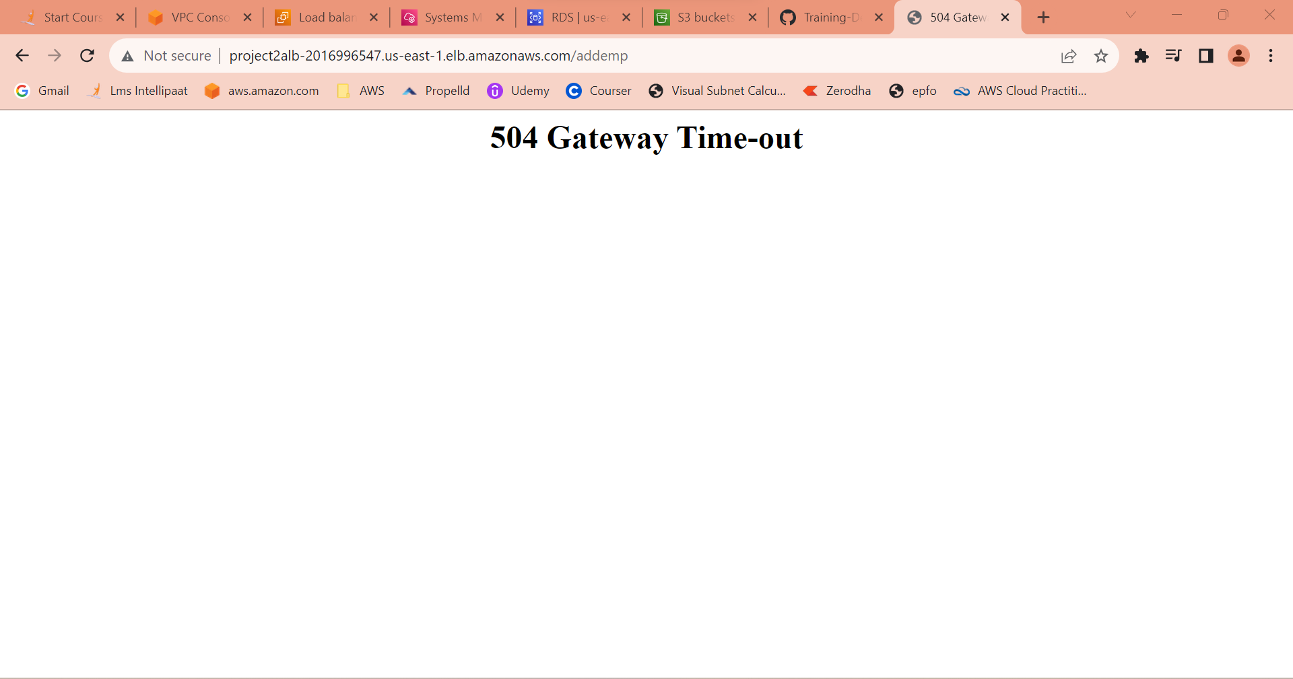

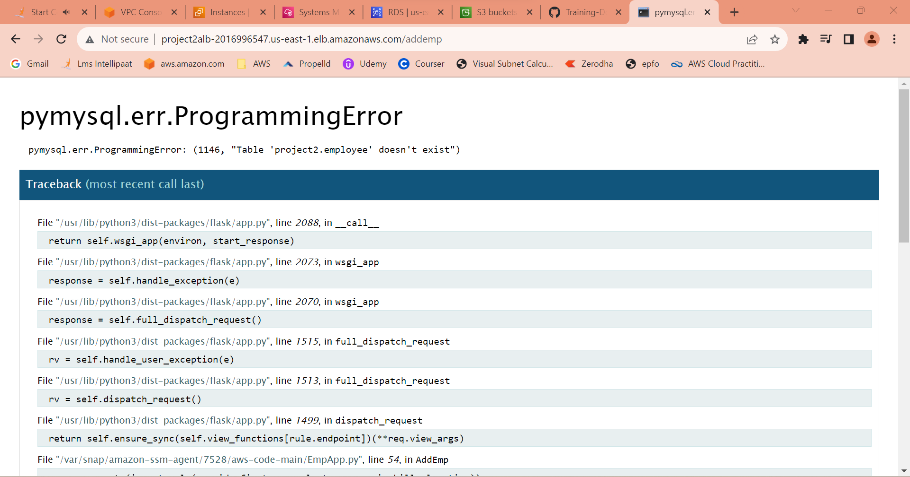

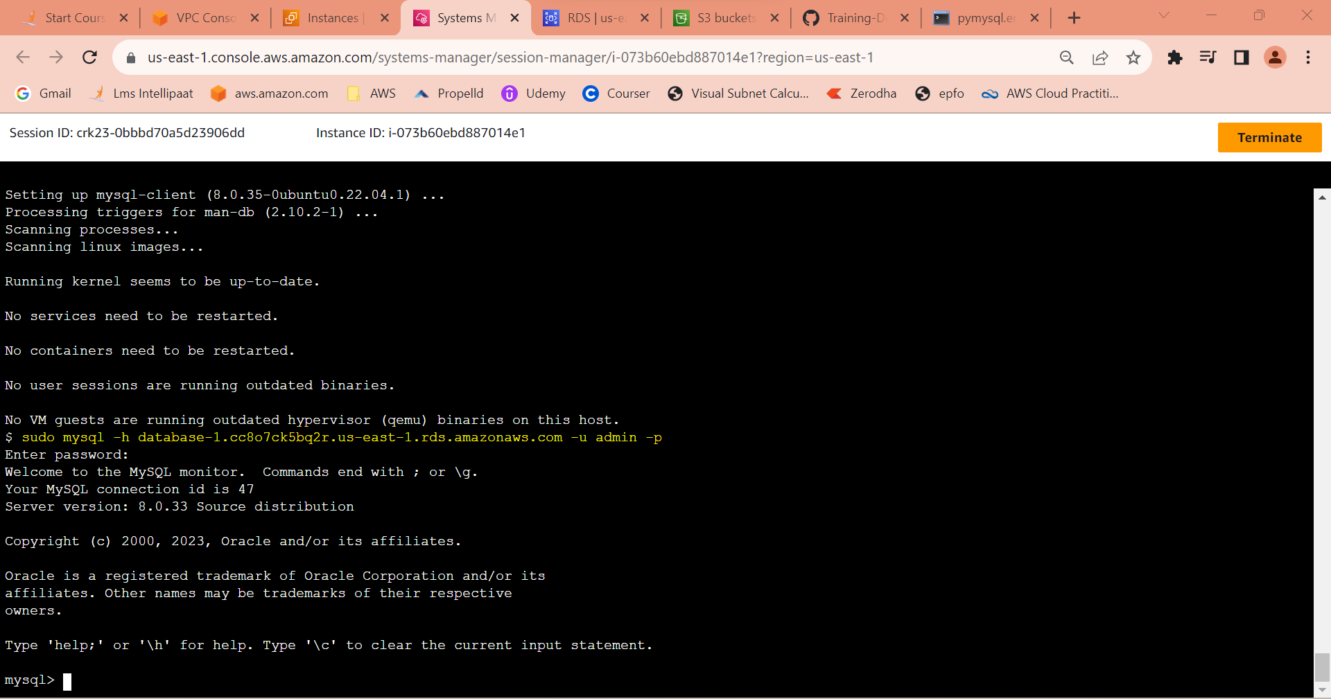

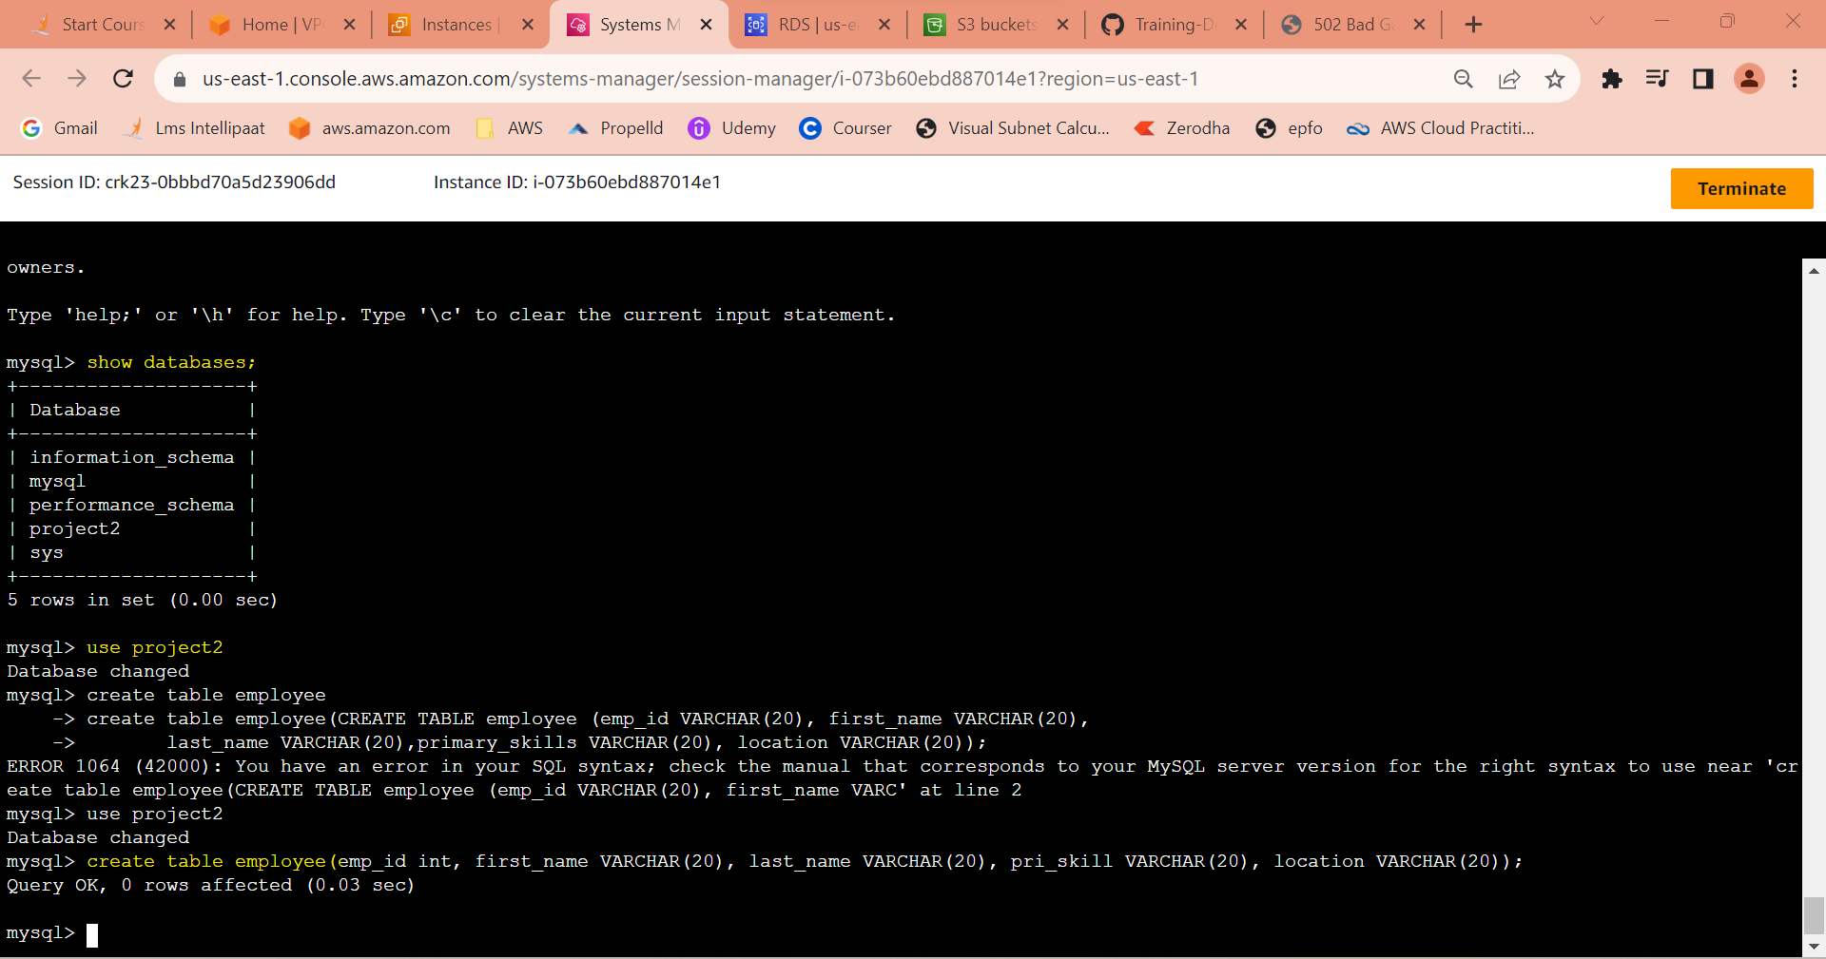

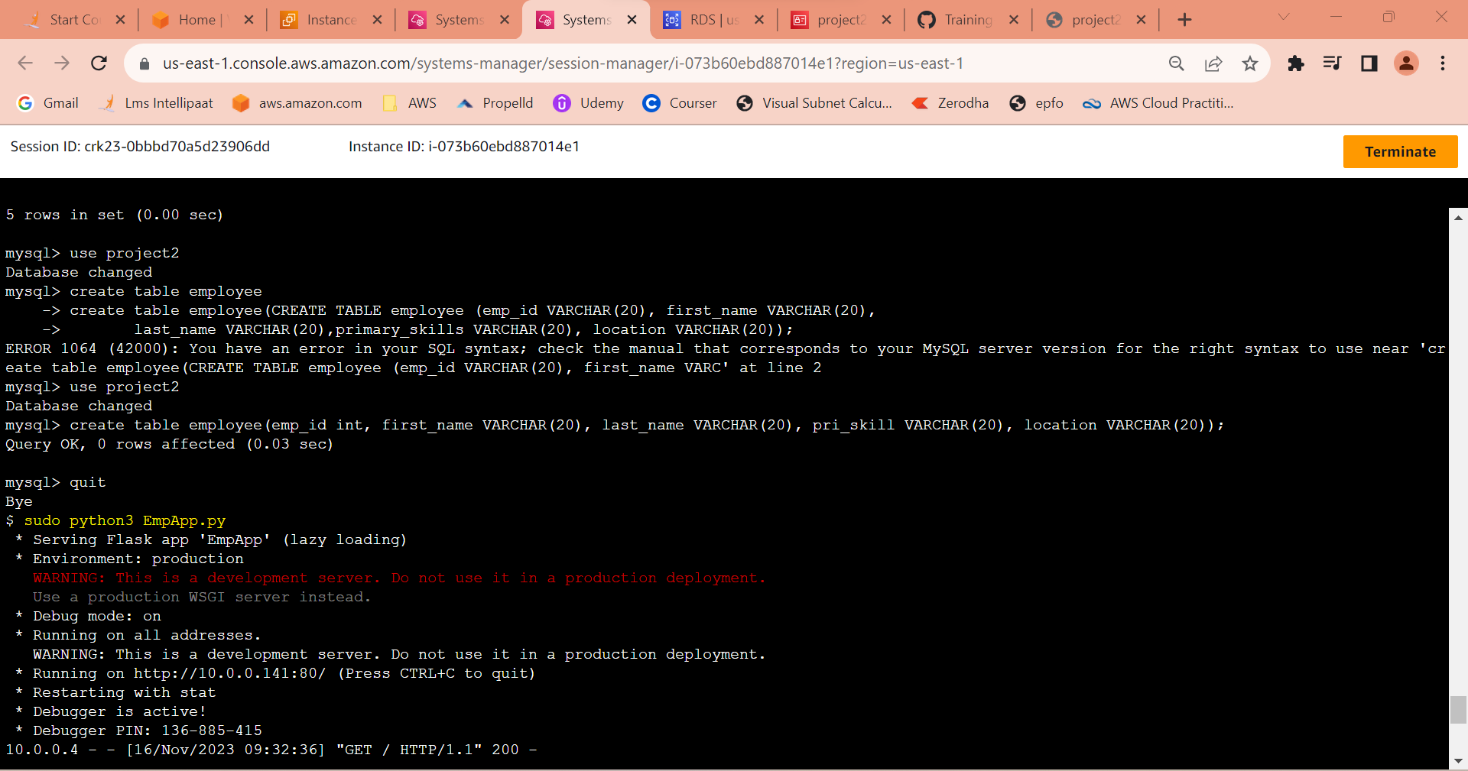

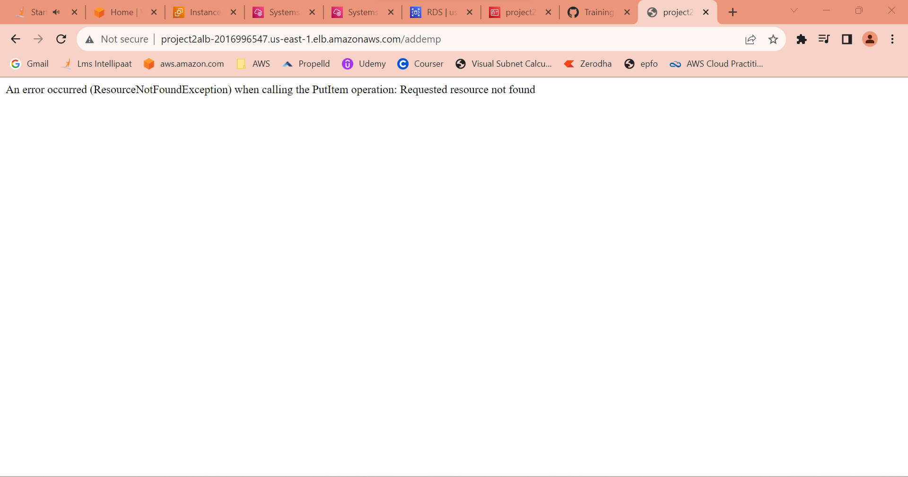

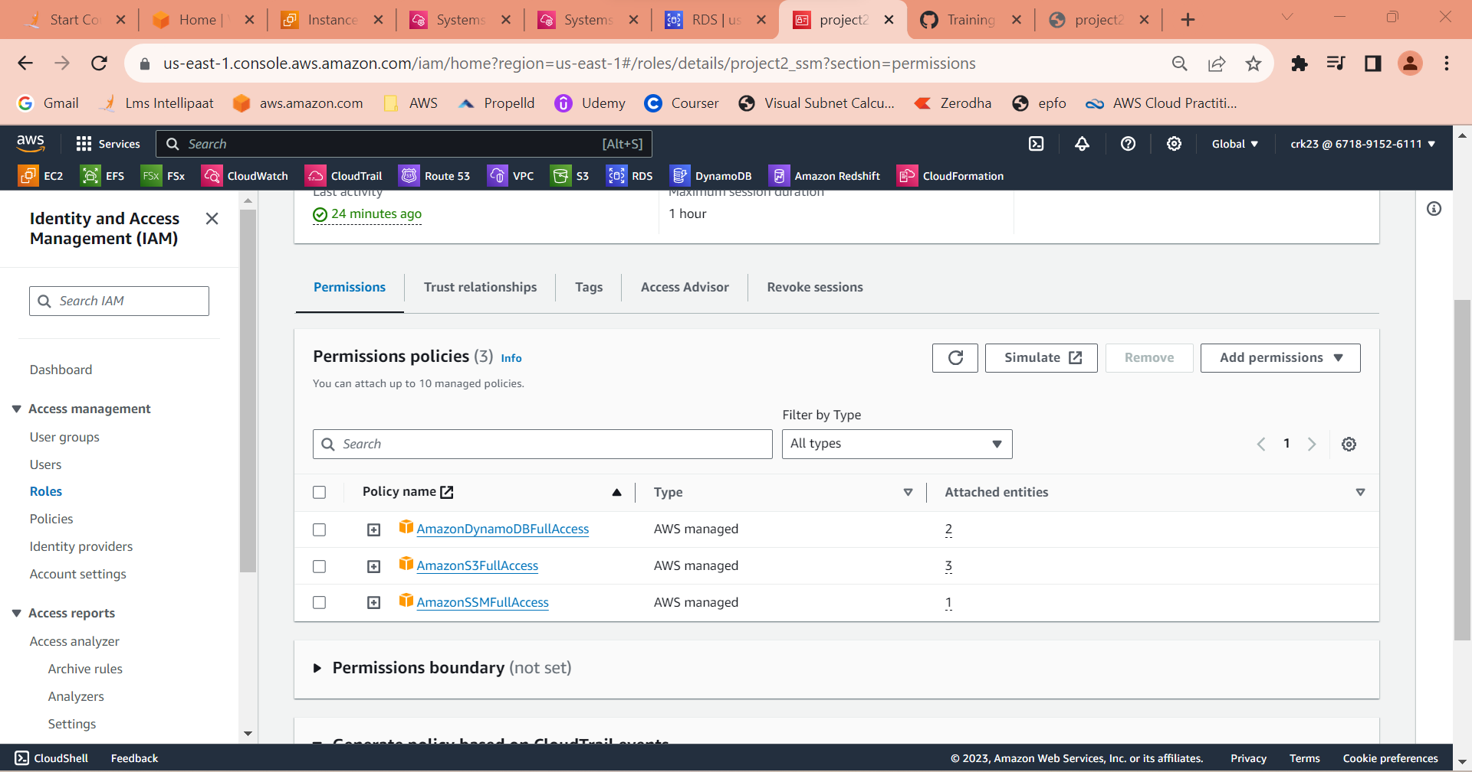

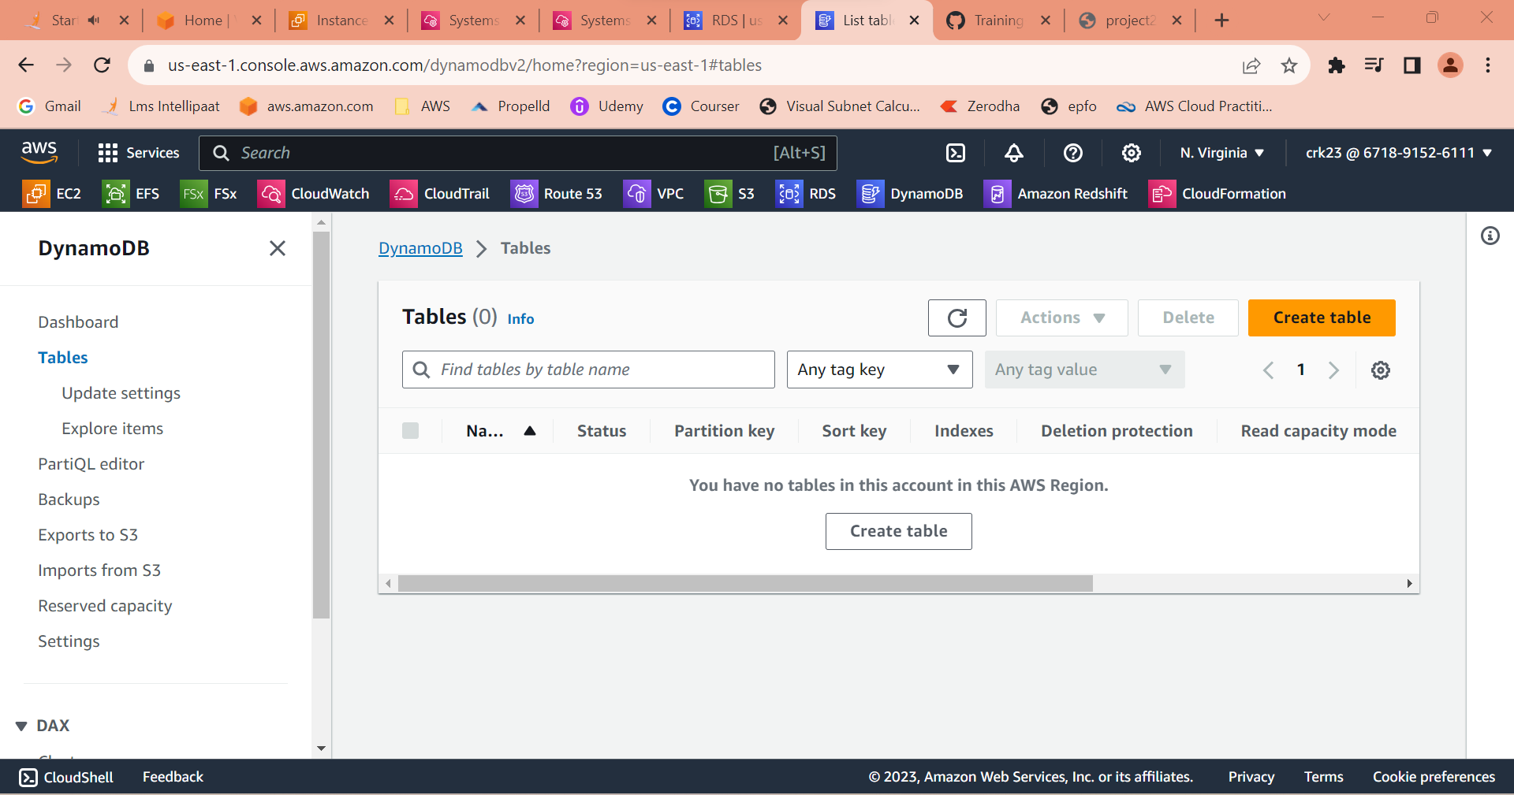

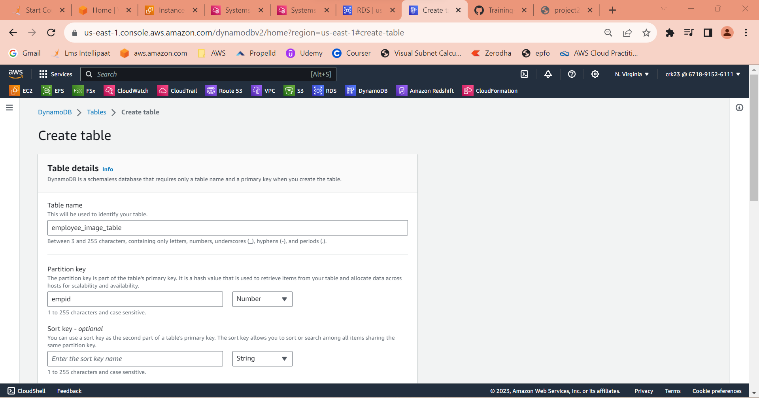

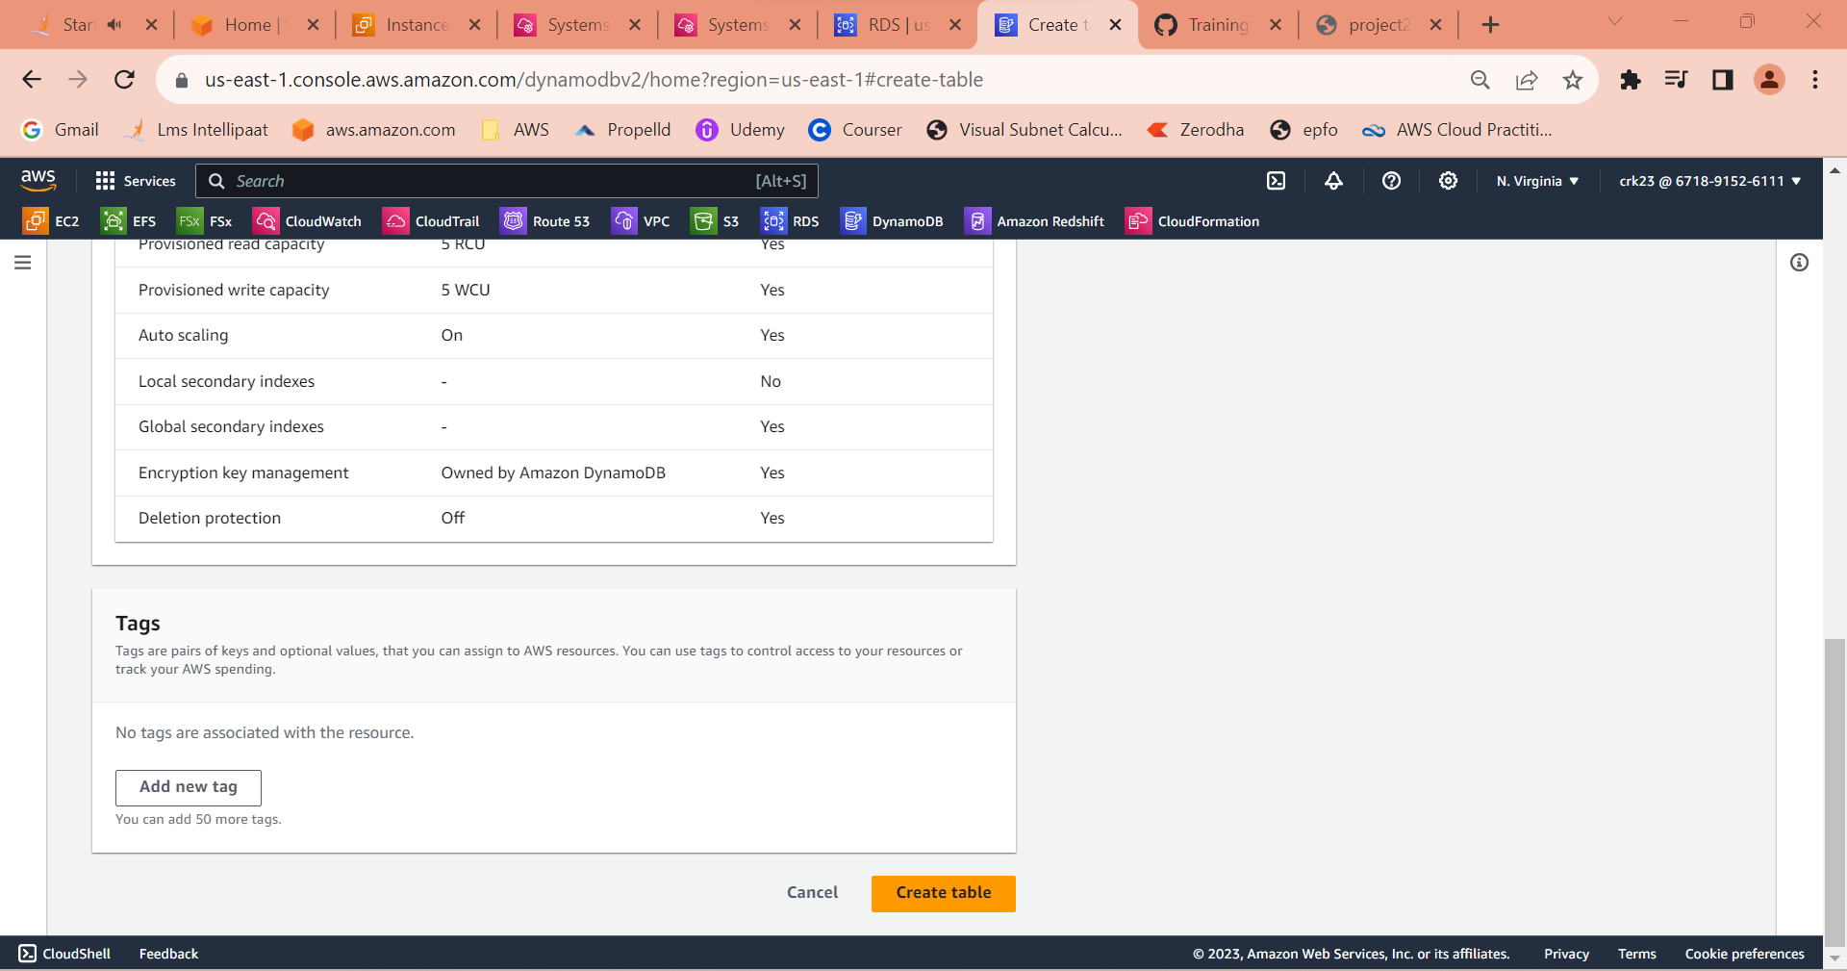

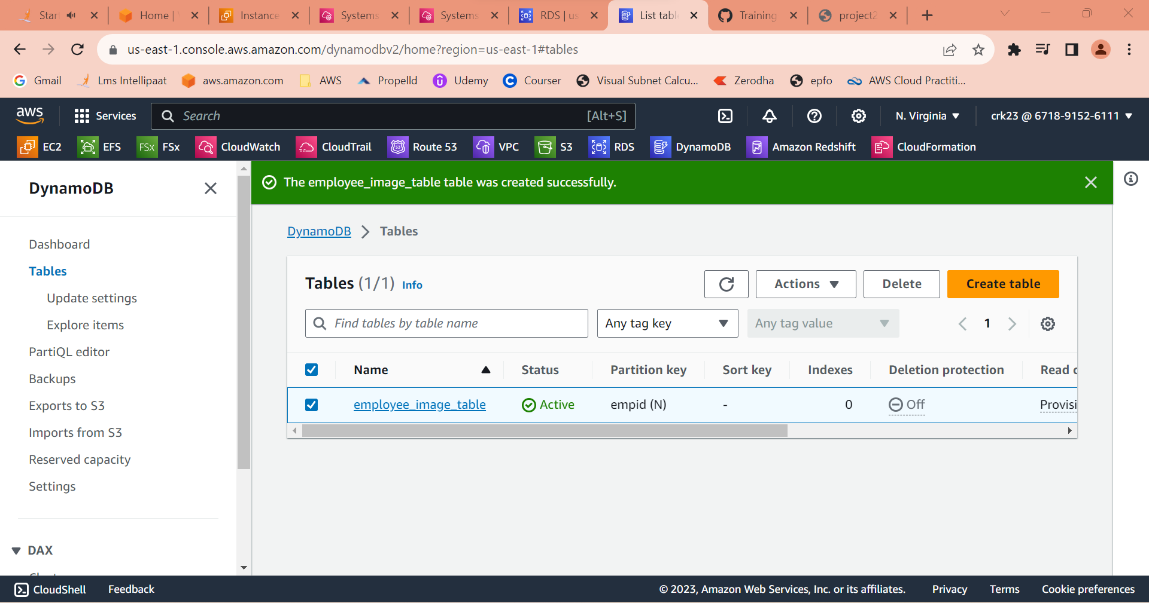

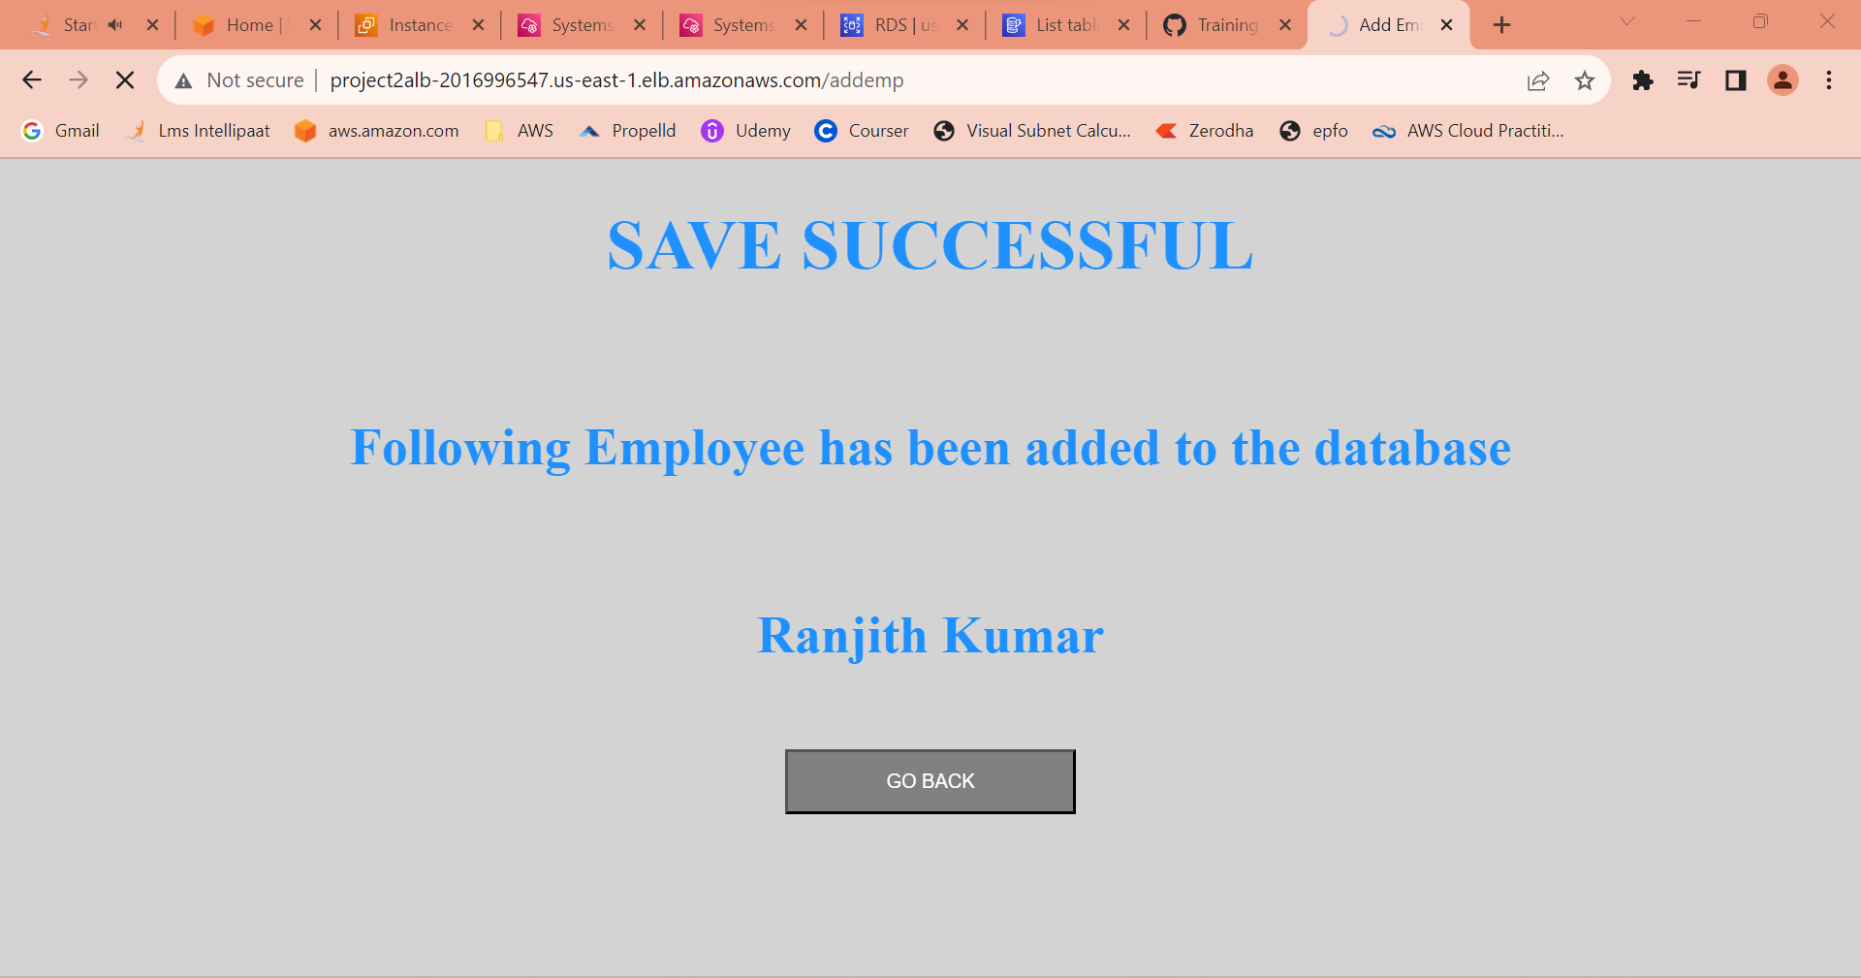

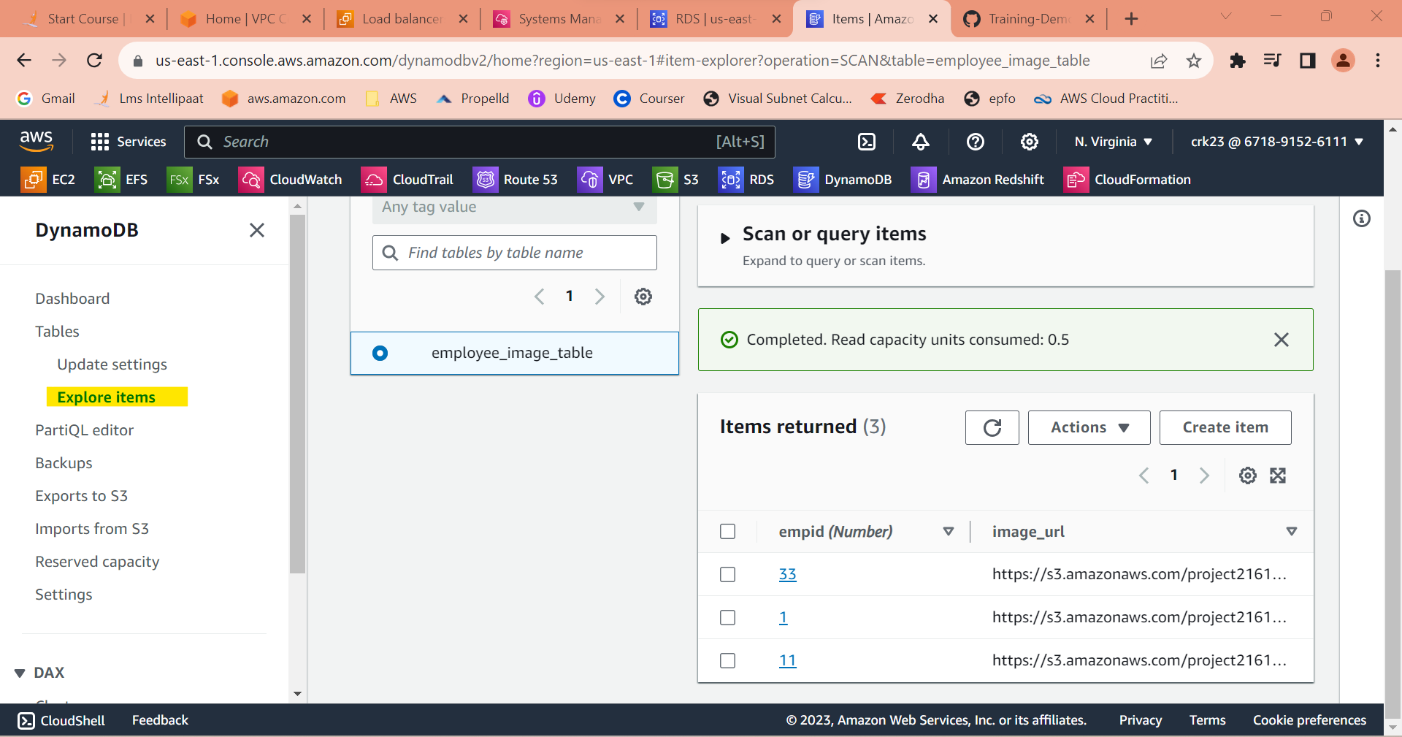

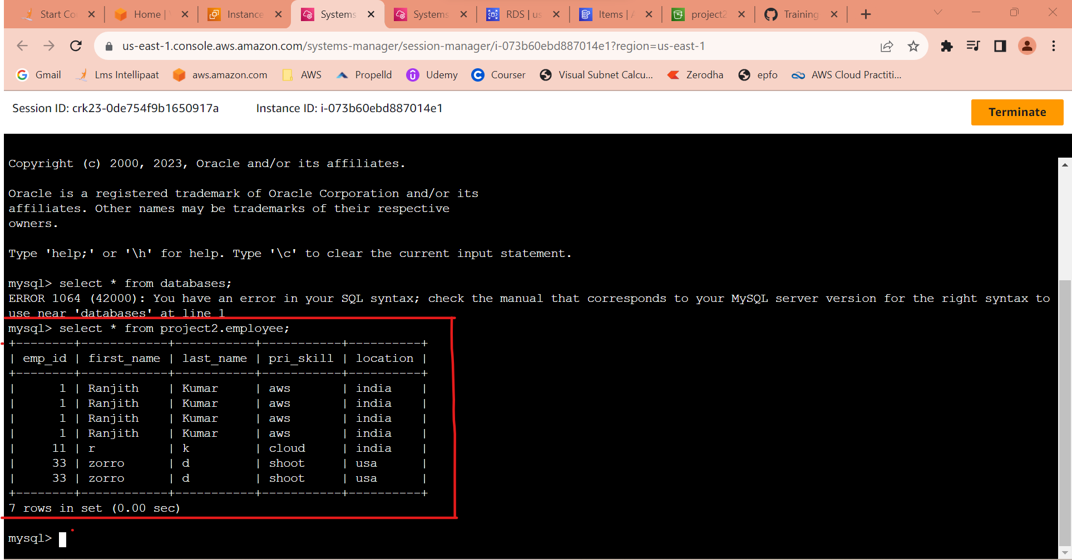

**Architecture**

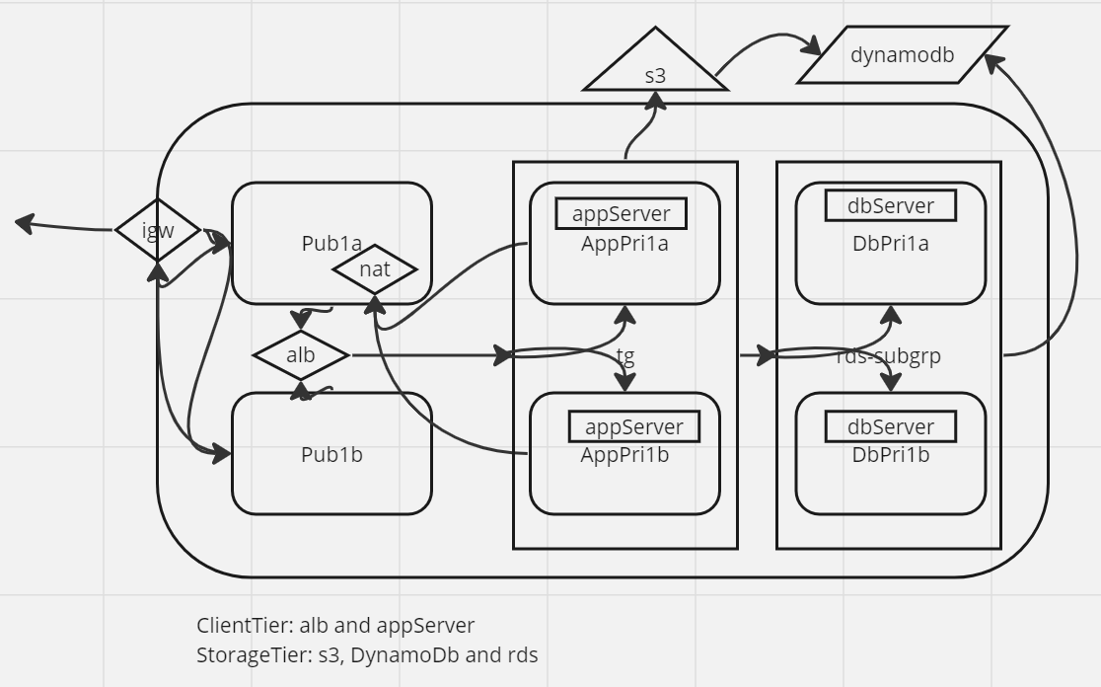

**OUTPUT:**

Created a client server(Application load balancer and App server) and storage tier(S3, dynamoDB, RDS) done successfully.